Dynamics and Inclined Planes
If a particle is in motion, $F = F_{max} = μR$, and $F$ opposes the direction of motion.
- Draw a force diagram
- Use Newton's 2nd law to resolve parallel and perpendicular to the plane
- Use SUVAT to solve problems if $F$ (and therefore $a$) are constant

Example (EdExcel M1 Jan 2010 Q5)
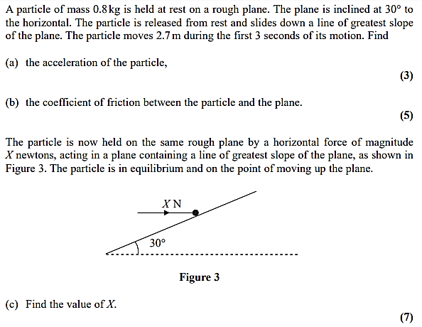

Test Your Understanding (EdExcel M1 May 2013(R) Q5)
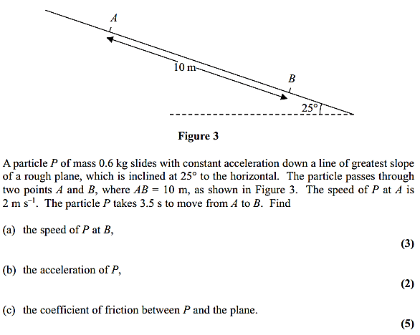

Exercise 7E Page 148

