- Static Rigid Bodies
Recall from the chapter on moments that for a stationary rigid body:
- The resultant force is 0.
- The resultant moment is 0.
The problems are the same as in the moments chapter, except now we may need to consider frictional forces.

Example
A uniform rod $AB$ of mass 45kg and length 12m rests with the end $A$ on rough horizontal ground. The rod rests against a smooth peg $C$ where $AC=8$ m. The rod is in limiting equilibrium at an angle of $15°$ to the horizontal. Find:
- the magnitude of the reaction of $C$
- the coefficient of friction between the rod and the ground.

Example (EdExcel M2 Jan 2012 Q5)
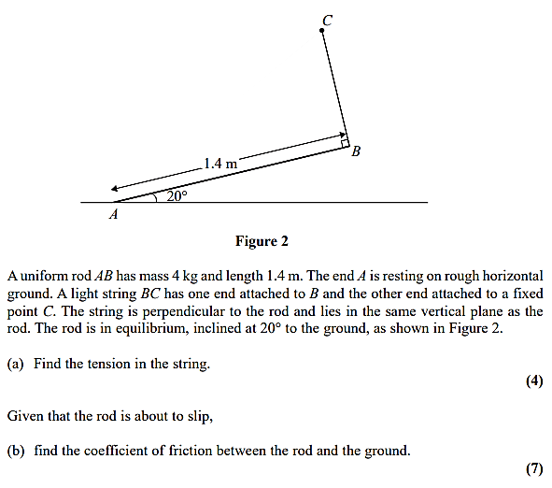

Test Your Understanding (EdExcel M2 Jan 2013 Q3)
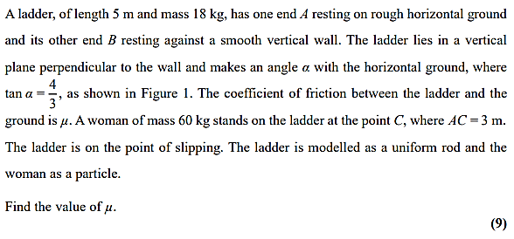
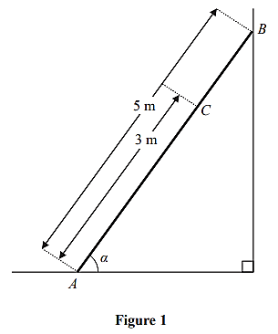

Exercise 7D Page 144

