7D Hinges
- A Plank AB of mass M and length 2a, rests with its end A against a rough vertical wall. The plank is held in a horizontal position by a rope. One end of the rope is attached to the plank and the other end is attached to the wall at the point C, which is vertically above A.

A small block of mass 3M is placed on the plank at the point P, where AP = x. The plank is in equilibrium in a vertical plane which is perpendicular to the wall. The angle between the rope and the plank is $α$, where tan$\left(α\right)=\frac{3}{4}$, as shown.

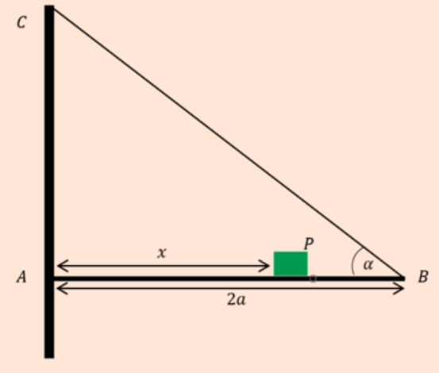

The plank is modelled as a uniform rod, the block is modelled at a particle and the rope is modelled as a light inextensible string.

- Using the model, show that the tension in the rope is

$$\frac{5Mg(3x+a)}{6a}$$

The magnitude of the horizontal component of the force exerted on the plane AB by the wall is 2Mg.
- Find x in terms of a

The forces exerted on the plank by the wall acts in a direction which makes an angle $β$ with the horizontal.
- Find the value of tan $β$

The rope will break if the tension in it exceeds 5Mg.
- Explain how this will restrict the possible values of P

