Modelling with Statics
Remember to include additional forces such as weight, tension, thrust, normal reaction, friction etc.

Example
A light, inextensible string of length 50cm has its upper end fixed at a point A and comes with a particle of mass 8kg at its lower end. A horizontal force P applied to the particle keeps it in equilibrium 30cm from the vertical through A.

By resolving horizontally and vertically, find the magnitude of P and the tension in the string.

Example
A light, inextensible string passes over a smooth pulley fixed at the top of a smooth plane inclined at 30^{O} to the horizontal. A particle of mass 2kg is attached to one end of the string and hangs freely. A mass m is attached to the other end of the string and rests in equilibrium on the surface of the plane.
Calculate the normal reaction between the mass m and the plane, the tension in the string and the value of m.

Test Your Understanding (EdExcel M1 May 2013(R) Q2)
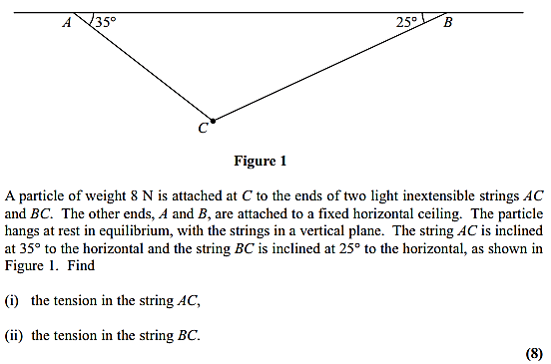
Exercise 7B Page 134

