7A Static Diagrams

- The particle in the diagram is in equilibrium. Calculate the magnitude of the forces P and Q.
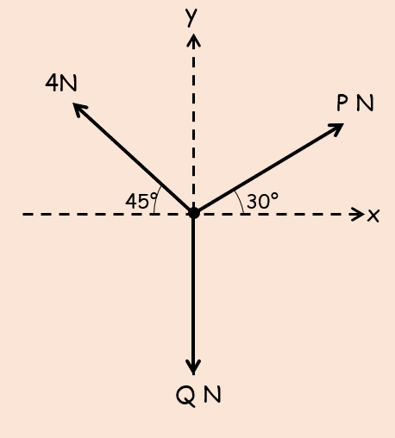

- The diagram shows a particle in equilibrium under a number of forces.
Calculate the magnitudes of the forces P and Q
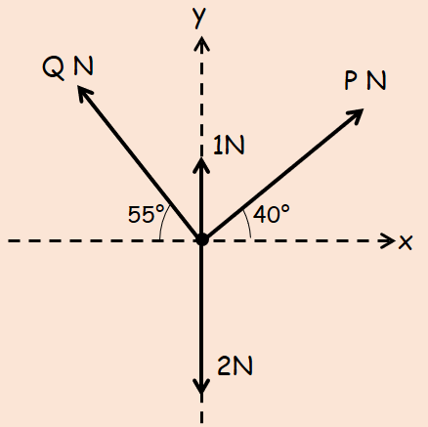

- The diagram shows a particle in equilibrium on an inclined plane under the effect of the forces shown.
Find the size of angle θ and the value of force P.
