A Level Mathematics
Chapter 7 - Mechanics
Applications of Forces
Chapter Overview
1. Static Particles
2. Modelling with Statics
3. Friction and Static Particles
4. Static Rigid Bodies
5. Dynamics and Inclined Planes
6. Connected Particles
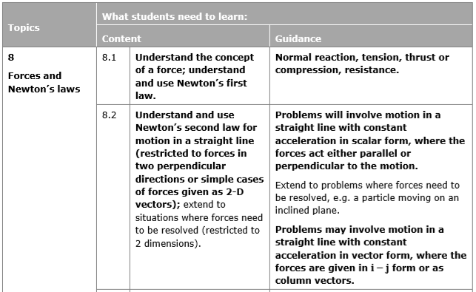
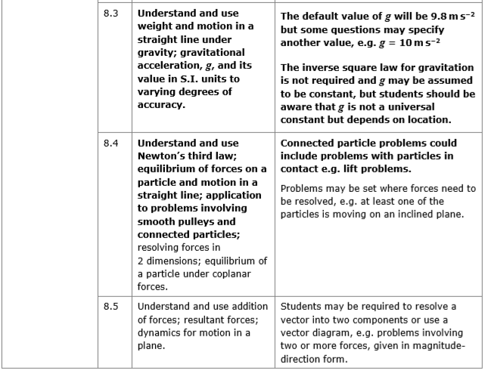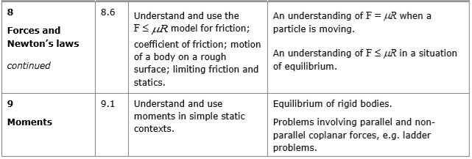
In this chapter, we will bring together everything that we have learned about forces: friction, resolving forces into components, Newton's 2nd law, inclined planes and connected particles, for different, common types of problems.

- Static Particles
If a particle is in equilibrium, the resultant of all forces is 0 and the particle remains at rest.

- Always draw a diagram
- Resolve the forces, horizontal and vertical, or parallel and perpendicular if on an inclined plane
- In each direction, sum of components = 0
- Solve the resulting equations to find unknown forces

For particles in equilibrium, you can also use a triangle of forces.

Example
The diagram shows a particle in equilibrium under the action of four forces as shown in the diagram below. The particle rests on an inclined plane which is set at an angle of 30° to the horizontal.

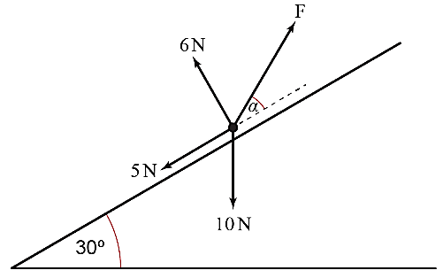
Find the magnitude of force F and the size of the angle, α, in degrees giving both answers to two significant figures.

Test Your Understanding
The diagram shows a particle in equilibrium on an inclined plane under the forces shown. Find the magnitude of the force $Q$ and the size of the angle $β$.
Exercise 7A Page 130

$$Q N$$
$$14 N$$
$$30°$$
$$6 N$$
$$5 N$$
$$β$$

Hint: Redraw the Q N force

