Projection motion Formulae
You must be able to derive general formulae related to the motion of a particle which is projected from a point on a horizontal plane and moves freely under gravity.

Deriving the Time of Flight (T) and the Range (R)

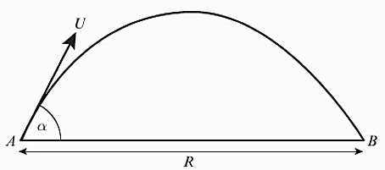

A particle is projected from a point on a horizontal plane with an initial velocity $U$ at an angle $α$ above the horizontal and moves freely under gravity until it hits the plane at point $B$.
Given that that acceleration due to gravity is $g$, find expressions for:
- the time of flight, $T$
- the range, $R$, on the horizontal plane.

Deriving the Equation of the Trajectory
When a particle is projected from a point O, on a horizontal plane, the equation of the trajectory may be obtained by taking x and y axes through the point of projection, O, as shown on the diagram.

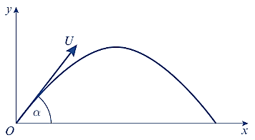

A particle is projected from a point with speed $U$ at an angle of elevation $α$ and moves freely under gravity. When the particle has moved a horizontal distance $x$, its height above the point of projection is $y$.
- Show that $y=x\tan{α -\frac{gx^{2}}{2u^{2}}\left(1+\tan^{2}{α}\right)}$
A particle is projected from a point $O$ on a horizontal plane, with speed 28 ms⁻¹ at an angle of elevation $α$. The particle passes through a point $B$, which is at a horizontal distance of 32m from $O$ and at a height of 8m above the plane.

(b) Find the two possible values of $α$, giving your answers to the nearest degree.

Exam Note: You may be asked to derive these. But don’t attempt to memorise them or actually use them to solve exam problems – instead use the techniques used earlier in the chapter.
For a particle projected with initial velocity $U$ at angle $α$ above horizontal and moving freely under gravity:
- Time of flight $=\frac{2U\sin{α}}{g}$
- Time to reach greatest height $=\frac{U\sin{α}}{g}$
- Range on horizontal plane $=\frac{U^{2}\sin{2α}}{g}$
- Equation of trajectory: $y=x\tan{α -\frac{gx^{2}}{2U^{2}}\left(1+\tan^{2}{α}\right)}$
where $y$ is vertical height of particle and $x$ horizontal distance.

Exercise 6D Page 123
Mixed Exercise 6 Page 125

