Projection at Any Angle
We can solve problems with particles projected at any angle by resolving the initial velocity into horizontal and vertical components.

Range = distance from point at which the particle was projected to the point where it strikes the horizontal plane

Time of Flight = time taken by particle to move from its point of projection to the point where it strikes the horizontal plane

A projectile reaches its point of greatest height when the vertical component of its velocity, $u_{y} = 0$.

Example
[Textbook] A particle $P$ is projected from a point $O$ on a horizontal plane with speed 28 ms⁻¹ and with angle of elevation $30°$. After projection, the particle moves freely under gravity until it strikes the plane at a point $A$. Find:
- the greatest height above the plane reached by $P$
- the time of flight of $P$
- the distance $OA$

Example
[Textbook] A particle is projected from a point $O$ with speed $V$ ms⁻¹ and at an angle of elevation of $θ$, where $\tan{θ=\frac{4}{3}}$. The point $O$ is 42.5m above a horizontal plane. The particle strikes the plane at a point $A$, 5 s after it is projected.
(a) Show that $V=20$. (b) Find the distance between $O$ and $A$.

Example
[Textbook] A particle is projected from a point $O$ with speed $35$ ms⁻¹ and at an angle of elevation of $30°$. The particle moves freely under gravity. Find the length of time for which the particle is 15 m or more above $O$.
Test Your Understanding (EdExcel M2 May 2012 Q7)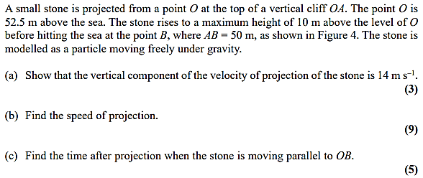
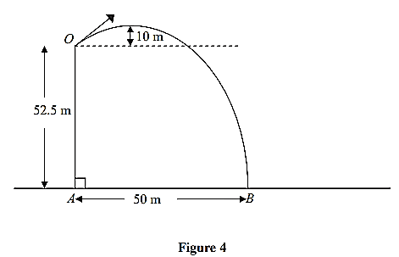

Exercise 6C Page 117

Extension Question:
A ball is projected from ground level at an angle of $θ$. Prove that when the ball hits the ground, the distance the ball has travelled along the ground is maximised when $θ=45°$.
(Year 2 differentiation knowledge required)

