- Horizontal and Vertical Components of Velocity
When a particle is projected with initial velocity U at an angle α above the horizontal:
- The horizontal component of the initial velocity is Ucosα
- The vertical component of the initial velocity is Usinα
- When the particle is at its highest point, the vertical velocity = 0.
- The speed of the object is the magnitude of the velocity vector.

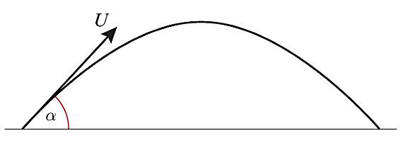
Example (Textbook Exercise 6B Q4)
A particle is projected from the top of a building with initial velocity of 28ms⁻¹ at an angle θ below the horizontal, where $\tan{θ}=\frac{7}{24}$.
a) Find the horizontal and vertical components of the initial velocity
b) Express the initial velocity as a vector in terms of i and j.

Exercise 6B Page 112

