A Level Mathematics
Chapter 6 - Mechanics
Projectiles
Chapter Overview
1. Horizontal Projection
2. Horizontal and Vertical Components
3. Projection at any Angle
4. Projectile Motion Formulae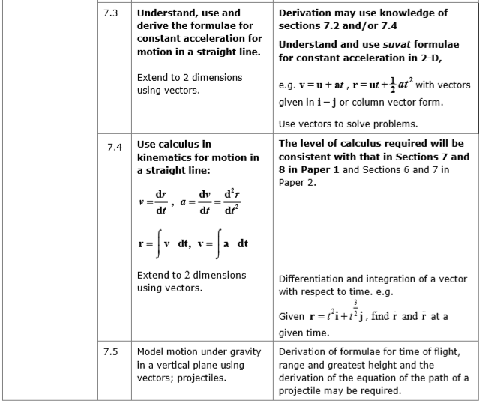

A particle moving in a vertical plane under gravity is sometimes called a projectile. You can use projectile motion to model the flight of e.g. a golf ball.

- Horizontal Motion
The horizontal motion of a projectile is modelled as having constant velocity ($a = 0$), so $s = vt$. Use $u_{x}$ and $v_{x}$ to denote horizontal velocity components.

The vertical motion of a projectile is modelled as having constant acceleration due to gravity ($a = g$). Use SUVAT - careful with directions! Use $u_{y}$ and $v_{y}$ to denote vertical velocity components.

Example
A ball is thrown horizontally with speed 20ms⁻¹, from the top of a building, which is 30m high. Find:
a) The time the ball takes to reach the ground.
b) The distance between the bottom of the building and the point where the ball hits the ground.

Example
A particle is projected horizontally with a velocity of 39.2ms⁻¹. Find the horizontal and vertical components of the velocity of the particle 3s after projection. Find also the speed and direction of the motion of the particle.
Exercise 6A Page 110

