Friction
Friction is a force which opposes motion between two rough surfaces.

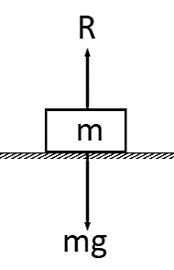
Scenario 1: A block is on a horizontal rough surface with no forces (other than gravity) acting on it.

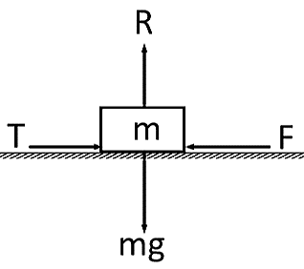
Scenario 2: A horizontal force is applied but it is not enough to move the block.

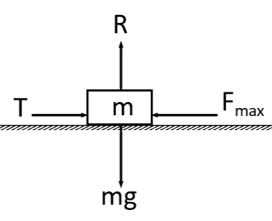

Scenario 3: T has reached or exceeded F_{max}, the maximum or limiting value for the friction.

Two things determine the maximum or limiting value, F_{max} between two surfaces:
$$F_{max}=μR$$

Example
A block of mass 5kg rests on a rough horizontal plane. The coefficient of friction between the block and the plane is 0.6.
Calculate the frictional force acting on the block when a horizontal force, P, is applied to the block and the magnitude of P is:
a) 12N
b) 29.4N
c) 36N

Also calculate the magnitude of any acceleration that may occur.

