5B Slopes on a Plane

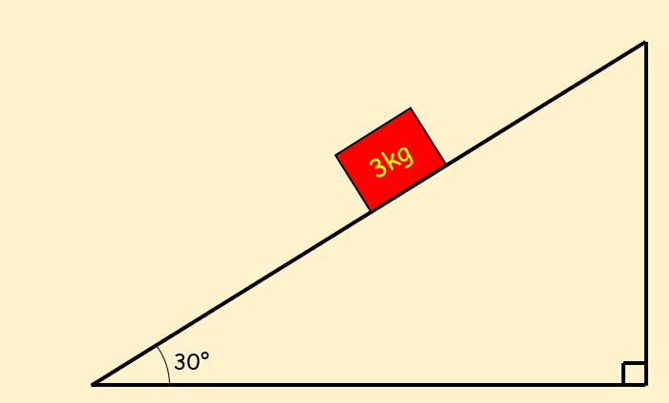

- A box of mass 2kg is resting on a smooth plane inclined at an angle of 20° to the horizontal. It meets resistance of 2N as it travels down the slope
- Calculate the acceleration of the box down the slope

- If the box starts 10m up the plane, calculate the velocity of the box at the bottom of the plane

- Find the normal reaction between the box and the plane

- A particle P of mass 2kg is moving on a smooth slope and is being acted on by a force of 4N that acts parallel to the slope as shown.
The slope is inclined at an angle $α$ to the horizontal, where $tanα=\frac{3}{4}$. Work out the acceleration of the particle.

- A particle of mass $m$ is pushed up a smooth slope by a force of magnitude 5g acting at an angle of 60˚ to the slope. This causes the particle to accelerate up the slope at 0.5ms⁻².
Show that the mass of the particle is $\left(\frac{5g}{1+g}\right) kg$

