- Inclined Planes
For problems involving inclined planes, we usually resolve forces parallel and perpendicular to the plane.
(For some problems where a particle is in equilibrium, it may be easier to resolve horizontally and vertically)

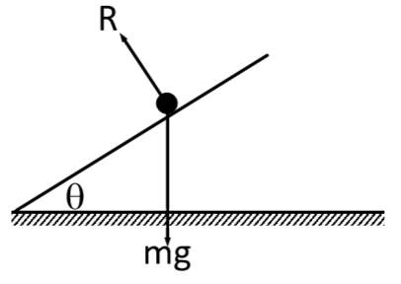
Smooth Plane
If there is no friction, the particle will slide down the slope.

Rough Plane
If rough enough, the force of friction might be enough to prevent the particle from moving.

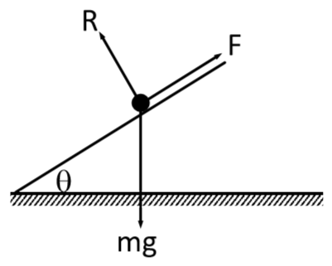

Remember:
- Weight always acts vertically downwards
- The normal reaction always acts perpendicular to the plane
- Friction always opposes the direction of motion

We have to resolve the weight into its components parallel and perpendicular to the plane.

Example
A block of mass 25kg slides down a smooth slope angled at 20° to the horizontal.
- Draw a force diagram to show all the forces acting on the block
- Calculate the magnitude of the normal reaction of the slope on the block.
- Find the acceleration.

Test your understanding
A block of mass 10kg slides down a smooth slope angled at 15° to the horizontal.
- Draw a force diagram to show all the forces acting on the block
- Calculate the magnitude of the normal reaction of the slope on the block.
- Find the acceleration.

Inclined Plane with an Additional Force
Example
A small parcel of mass 2 kg is held in equilibrium on a rough plane by a horizontal force of magnitude 20 N, acting in a vertical plane through a line of greatest slope. The plane is inclined at an angle of 20° to the horizontal. The parcel is modelled as a particle. The parcel is on the point of moving up the slope.
- Draw a force diagram to show all the forces acting on the parcel.
- Calculate the magnitude of the normal reaction of the slope on the parcel.

We can use Pythagoras to work out values for sin θ and cos θ if given tan θ.
Example (Textbook Page 98 Exercise 5B Question 3)
A particle of mass 0.5kg is held at rest on a smooth slope that is inclined at an angle of a to the horizontal. The particle is released. Given that $\tan{∝}=\frac{3}{4}$, calculate:
- The normal reaction between the particle and the plane
- The acceleration of the particle

Test Your Understanding (Textbook p97 Example 6)
A particle of mass $m$ is pushed up a smooth slope, inclined at $30°$ by a force of magnitude $5g$ N acting at angle of $60°$ to the slope, causing the particle to accelerate up the slope at 0.5 ms⁻². Show that the mass of the particle is $\left(\frac{5g}{1+g}\right)$ kg.

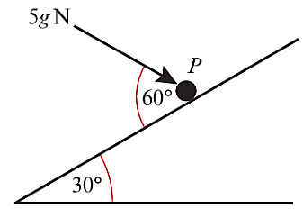

Hint: Redraw the 5g force

Exercise 5B Page 98

