5A Forces at Angles

- Find the component of each force in the x and y-directions.
Hence, write each force in the form $\left(pi+qj\right)N$

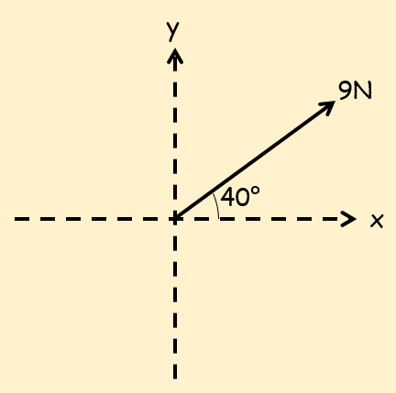

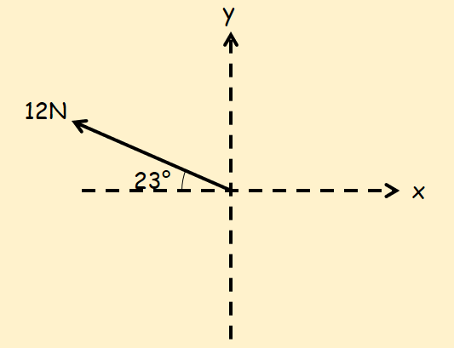

- A box of mass 8kg lies on a smooth horizontal floor. A force of 10N is applied at an angle of 30˚ causing the box to accelerate horizontally across the floor.
- Work out the acceleration of the box

- Calculate the normal reaction between the box and the floor

- Two forces, $P$ and $Q$, act upon a particle as shown in the diagram. Work out the magnitude and direction of the resultant force.
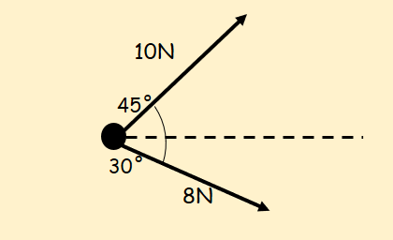

- Three forces act on a particle as shown. Given that the particle is in equilibrium, calculate the magnitude of $P$ and the value of $θ$.
