A Level Mathematics
Chapter 5 - Mechanics
Forces and Friction
Chapter Overview
1. Resolving Forces
2. Inclined Planes
3. Friction

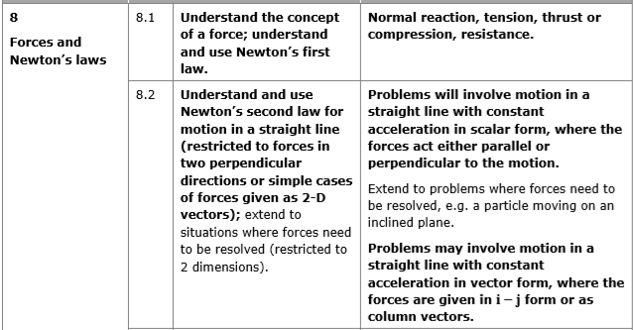
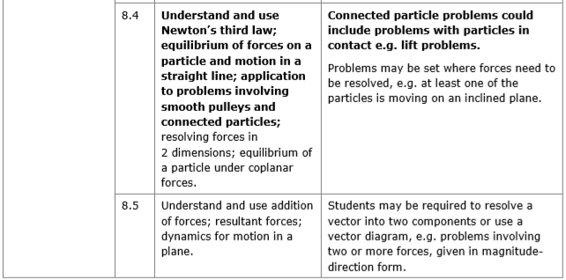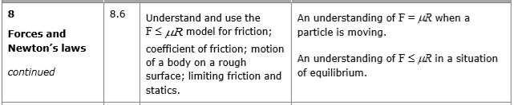

- Resolving Forces
If a force is applied at an angle to the direction of motion you can resolve it to find the component of the force that acts in the direction of motion.

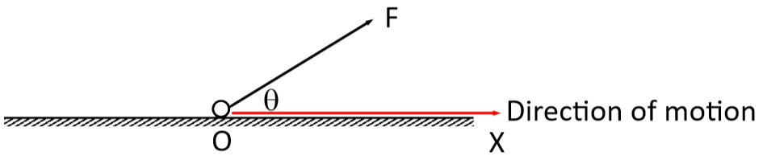

The component of a force, F, in any given direction is the measure of the effect of the force in that direction.
In the diagram above, the magnitude of the force in the horizontal and vertical direction can be calculated using trigonometry:

Rule of thumb:
Pull a force THROUGH an angle $⟹$ cos θ
Pull a force AWAY from an angle $⟹$ sin θ

Example
Find the sum of the components of the given forces in the direction of:
a) the x-direction
b) the y-direction

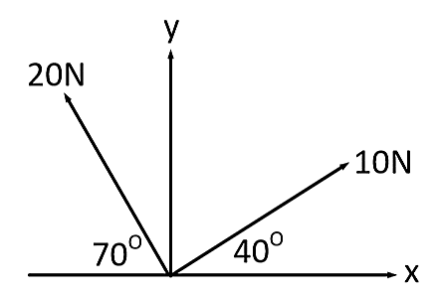

We can also draw a triangle of forces to solve problems for particles in equilibrium.

Example (Textbook Page 94 Example 4)
Three forces act on a particle as shown.
Given that the particle is in equilibrium, calculate the magnitude of P.

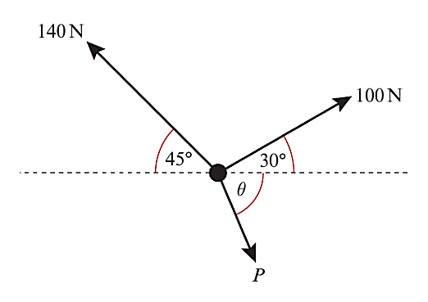

Applied Example
A force P is applied to a box of mass 5 kg, causing the box to accelerate at 2 m s⁻² along a smooth, horizontal plane. Given that the force causing the acceleration is applied at 30º to the plane, work out the value of P.

Exercise 5A Page 94

