- Tilting

When a rigid body is on the point of tilting about a pivot, the reaction
at any other support (or tension in any other wire/string) is zero.

Example
A uniform beam AB, of mass 12kg and length 6m rests on two pivots at P and Q, where AP = 1m and QB = 1.5m.
A particle of M kg is placed at A and the beam is about to tilt about the pivot at P. Find the mass of the particle and the reaction force at P.

Test Your Understanding – Suspended System (Textbook)
A non-uniform rod $AB$, of length 10 m and weight 40 N, is suspended from a pair of light cables attached to $C$ and $D$ where $AC=3$ m and $BD=2$ m.
When a weight of 25 N is hung from $A$ the rod is on the point of rotating.
Find the distance of the centre of mass of the rod from $A$.

Test Your Understanding (EdExcel M1 May 2013 Q6)
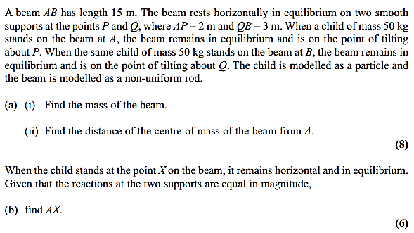

Exercise 4E Page 84
Mixed Exercise 4 Page 85

