- Centres of Mass (Non-Uniform Bodies)
The mass of a non-uniform rigid body can be modelled as acting at its centre of mass.

Example
Sam and Tasmin are sitting on a non-uniform plank AB, of mass 28kg and length 5m. The plank is pivoted at M, the midpoint of AB. The centre of mass of AB is at C, where AC is 2.2m. Sam has mass 40kg. Tasmin has mass 35kg and sits at A. Where must Sam sit for the plank to be horizontal?

Make sure that you put all the forces on the diagram.

Example
Two sand bags of masses 7kg and 3kg are placed on the ends of a non-uniform rod PQ, of mass 8kg and length 4m, with the 7kg mass placed at P.
The rod rests in equilibrium on the edge of a smooth table, with half of the rod lying on the table's surface. Find the distance of the centre of mass from the edge of the table and the reaction force of the table on the rod.
If the rod were to tilt, where would it pivot? This will be where the reaction of the table on the rod is positioned.

Test Your Understanding (EdExcel M1 May 2012 Q2)

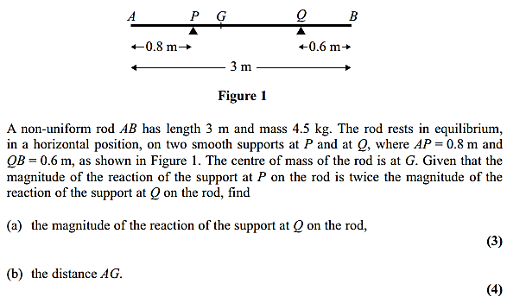

Exercise 4D Page 81

