4C Uniform Rods

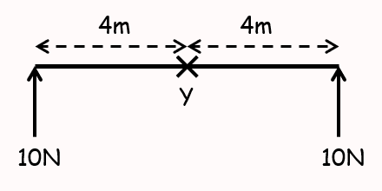

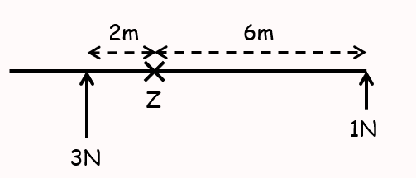

- The diagram shows a uniform rod of length 3m and weight 20N resting horizontally on supports at A and C, where AC = 2m.
Calculate the magnitude of the normal reaction at both of the supports
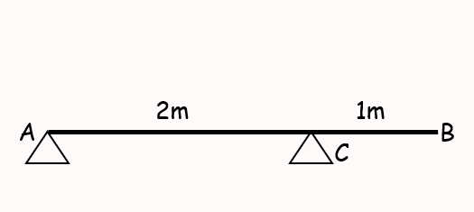

- A uniform beam, AB, of mass 40kg and length 5m, rests horizontally on supports at C and D where AC = DB = 1m.
When a man of mass 80kg stands on the beam at E, the magnitude of the reaction at D is double the reaction at C.
By modelling the beam as a rod and the man as a particle, find the distance AE

- A uniform rod $PQ$ is hinged at the point $P$, and is held in equilibrium at an angle of 50˚ to the horizontal by a force of magnitude F acting perpendicular to the rod at $Q$. Given that the rod has a length of 3m and a mass of 8kg, find the value of $F$.
