Equilibrium
If a rigid body is in equilibrium:

1.

2.

Example
AB is a uniform rod of length 5m and weight 20N. AB is resting in a horizontal position on supports at C and D. Find the magnitude of the reactions at C and D.

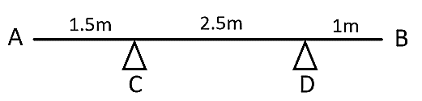

Example
A uniform beam AB, of length 2m and mass 4kg, has a mass of 3kg attached to one end and a mass of 1kg attached at the other end. Find the position of the support C, if the beam rests in a horizontal position.

Remember to include all forces on your force diagram.
There are two ways to solve this problem:

1) Take moments about C
2) Resolve forces to find the reaction at C, then take moments about one end

Test Your Understanding (Textbook)
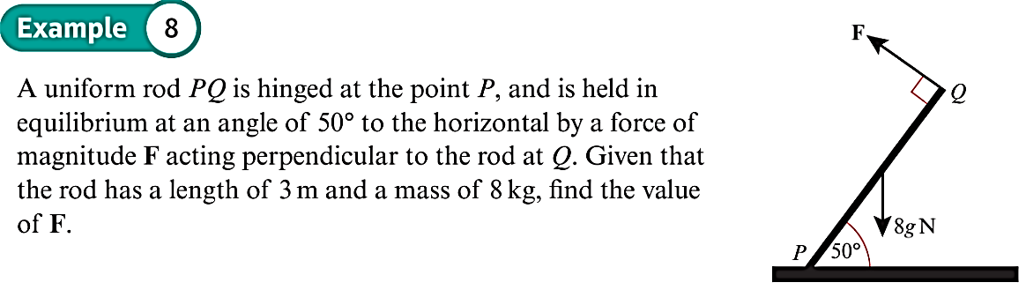

Test Your Understanding (EdExcel M1 May 2013 (R) Q8)
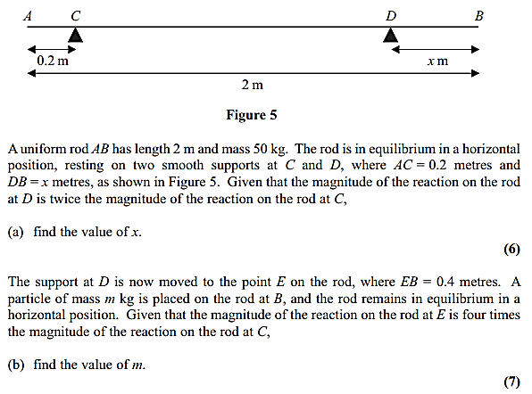

Exercise 4C Page 78

