Using Partial Fractions

Example
1.
- Express $\frac{4-5x}{\left(1+x\right)\left(2-x\right)}$ as partial fractions.
- Hence show that the cubic approximation of $\frac{4-5x}{\left(1+x\right)\left(2-x\right)}$ is $2-\frac{7}{2}x+\frac{11}{4}x^{2}-\frac{25}{8}x^{3}$
c) State the range of values of $x$ for which the expansion is valid.

Test Your Understanding
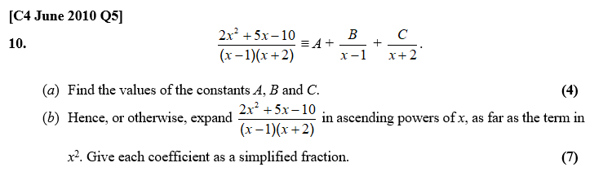
Exercise 4C Page 102

