4B Multiple Moments

- Calculate the sum of the moments acting about the point P
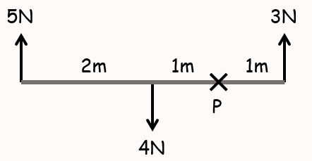

- Calculate the sum of the moments acting about the point P
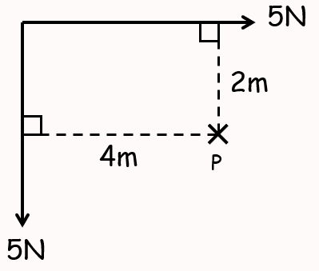

- The diagram to the right shows 3 forces acting on a light rod.
Find the resultant moment about point P
(ie – if the rod were fixed at point P, how would it rotate?)
