Resultant Moments
If several coplanar forces act on a body, you can add the moments about a point. Choose a positive direction (clockwise or anti-clockwise) and consider the sense of rotation of each moment.

Example
Find the sum of moments about the point O, of the forces acting in each diagram:

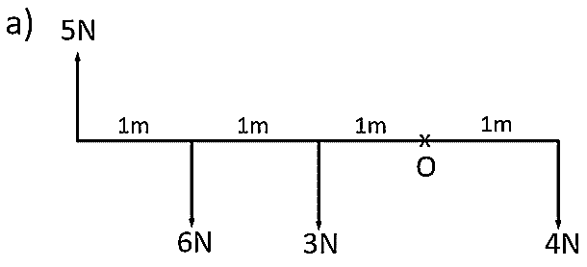

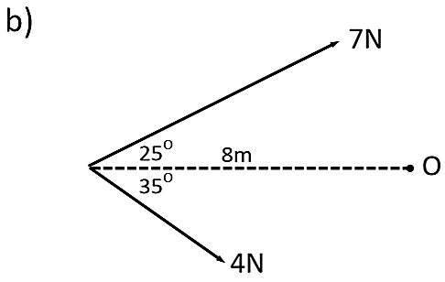

Resolving a Force into its Parallel and Perpendicular Components to Find its Moment
This can be a useful technique for harder problems. We can use trig to find the perpendicular distance of a force from a point of rotation, but we can also split the force into its parallel and perpendicular components.

Example
Find the moment of the force about point P.

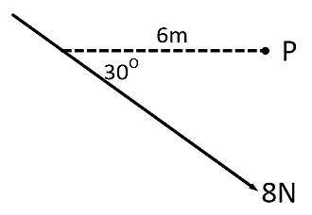

Exercise 4B Page 74

