4A Moments Introduction

- Find the Moment about C
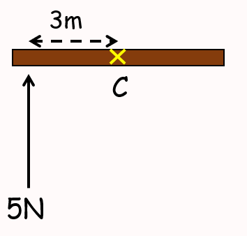

- Calculate the moment of the force about point F
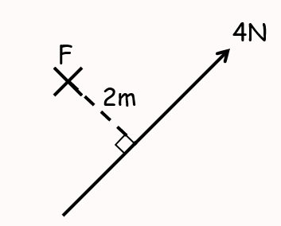

- Calculate the moment of the force about point A
