A Level Mathematics
Chapter 4 - Mechanics
Moments
Chapter Overview
1. Moments
2. Resultant Moments
3. Equilibrium
4. Centres of Mass
5. Tilting

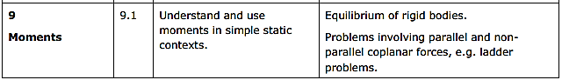

- Moments
The moment of a force is the turning effect of the force on the body on which it is acting.

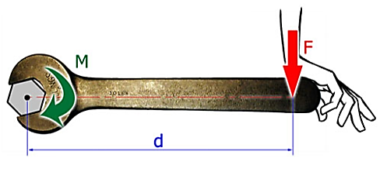
The moment is dependent on:
- The magnitude of the force
- The distance of the force from the axis of rotation

Moment of force =

You must also give the direction of the force.
Example
In each diagram, find the moment of the force, F, about the point P.

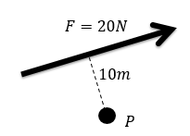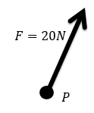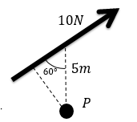

Test Your Understanding (Textbook))
The diagram shows two forces acting on a lamina. Find the moment of each of the forces about P.

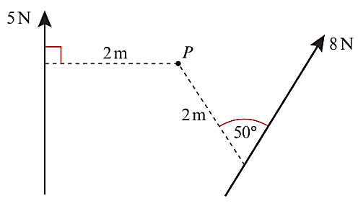

Exercise 4A Page 72

