Modelling
Examples
1. Bruce starts a new company. In year 1 his profits will be £20 000. He predicts his profits to increase by £5000 each year, so that his profits in year 2 are modelled to be £25 000, in year 3, £30 000 and so on. He predicts this will continue until he reaches annual profits of £100 000. He then models his annual profits to remain at £100 000.
- Calculate the profits for Bruce’s business in the first 20 years.
- State one reason why this may not be a suitable model.
- Bruce’s financial advisor says the yearly profits are likely to increase by 5% per annum. Using this model, calculate the profits for Bruce’s business in the first 20 years.

2. A piece of A4 paper is folded in half repeatedly. The thickness of the A4 paper is 0.5 mm.
- Work out the thickness of the paper after four folds.
- Work out the thickness of the paper after 20 folds.
- State one reason why this might be an unrealistic model.

Test Your Understanding
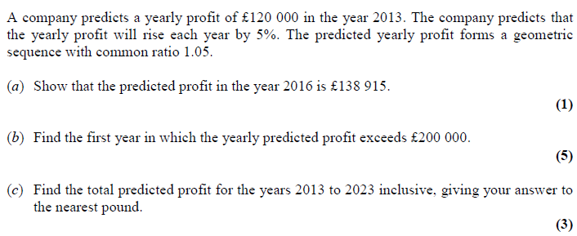

Extension
AEA 2007 Q5
The figure shows part of a sequence $S_{1}, S_{2}, S_{3},…$, of model snowflakes. The first term $S_{1}$ consist of a single square of side $a$. To obtain $S_{2}$, the middle third of each edge is replaced with a new square, of side $\frac{a}{3}$, as shown. Subsequent terms are added by replacing the middle third of each external edge of a new square formed in the previous snowflake, by a square $\frac{1}{3}$ of the size, as illustrated by $S_{3}$.
a) Deduce that to form $S_{4}$, 36 new squares of side $\frac{a}{27}$ must be added to $S_{3}$.
b) Show that the perimeters of $S_{2}$ and $S_{3}$ are $\frac{20a}{3}$ and $\frac{28a}{3}$ respectively.
c) Find the perimeter of $S_{n}$.

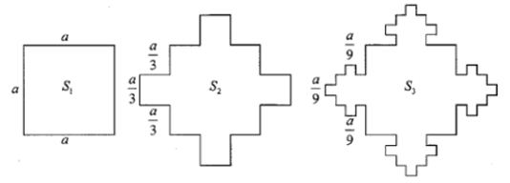

Ex 3I Pg 84

