Recurrence Relations

Example

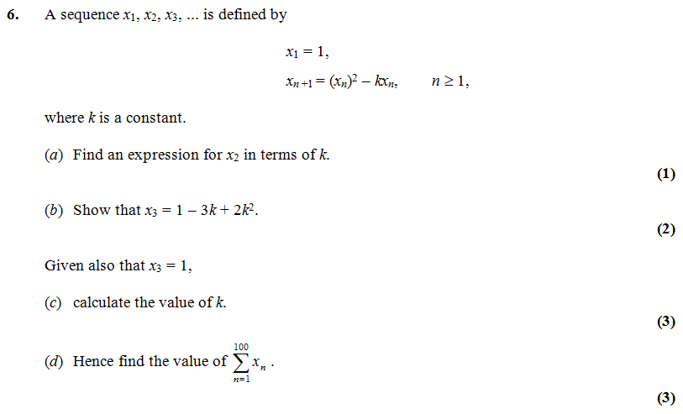

Test Your Understanding

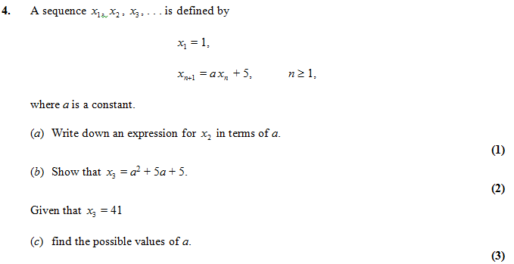

Combined Sequences

Sequences (or series) can be generated from a combination of both an arithmetic and a geometric sequence.

Example



Extension

1. *[AEA 2011 Q3]* A sequence $\{u_{n}\}$ is given by

$$u_{1}=ku_{2n}=u_{2n-1}×p, n≥1u_{2n+1}=u_{2n}×q n≥1$$

1. Write down the first 6 terms in the sequence.
2. Show that $\sum_{r=1}^{2n}{u_{r}}=\frac{k\left(1+p\right)\left(1-{\left(pq\right)}^{n}\right)}{1-pq}$

$[x]$ means the integer part of $x$, for example .  
Find

2. [MAT 2014 1H] The function $F\left(n\right)$ is defined for all positive integers as follows: $F\left(1\right)=0$ and for all $n≥2$,

$F\left(n\right)=F\left(n-1\right)+2$ if 2 divides $n$ but 3 does not divide $,$

$F\left(n\right)=F\left(n-1\right)+3$ if 3 divides $n$ but 2 does not divide $n,$

$F\left(n\right)=F\left(n-1\right)+4$ if 2 and 3 both divide $n$

$F\left(n\right)=F\left(n-1\right)$ if neither 2 nor 3 divides $n$.

Then the value of $F\left(6000\right)$ equals what?

3. [MAT 2016 1G] The sequence $\left(x_{n}\right)$, where $n≥0$, is defined by $x_{0}=1$ and

$x_{n}=\sum_{k=0}^{n-1}{\left(x_{k}\right)}$ for $n≥1$

Determine the value of the sum $\sum_{k=0}^{∞}{\frac{1}{x_{k}}}$

Ex 3G Pg 80