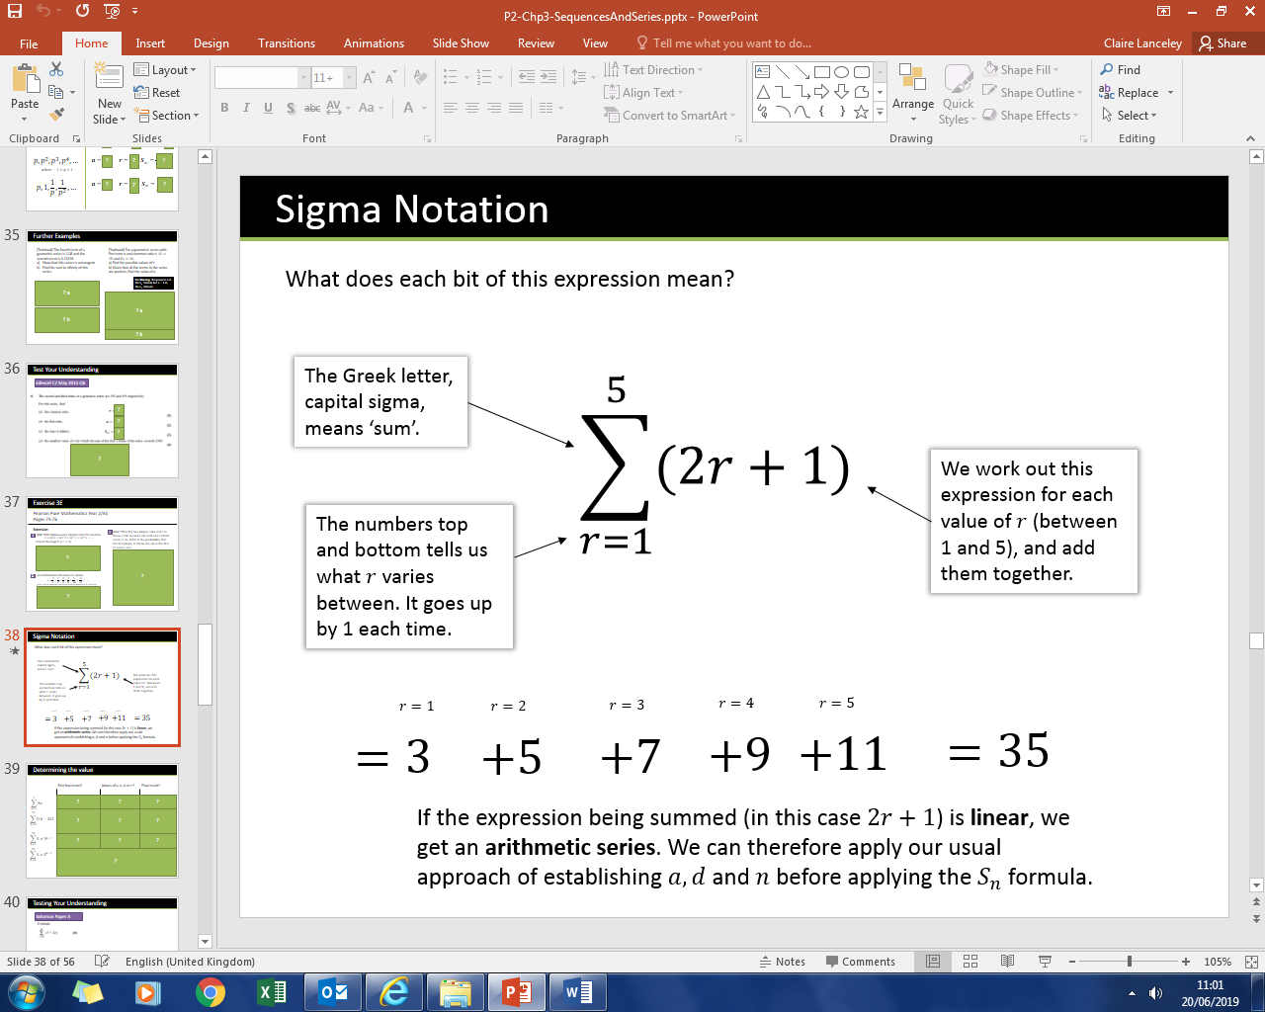Sigma Notation

|  |  |  |  |
| --- | --- | --- | --- |
|  | First few terms? | Values of $a, n, d or r$? | Final result? |
| $$\sum_{n=1}^{7}{3n}$$ |  |  |  |
| $$\sum_{k=5}^{15}{\left(10-2k\right)}$$ |  |  |  |
| $$\sum_{k=1}^{12}{5×3^{k-1}}$$ |  |  |  |
| $$\sum_{k=5}^{12}{5×3^{k-1}}$$ |  |  |  |

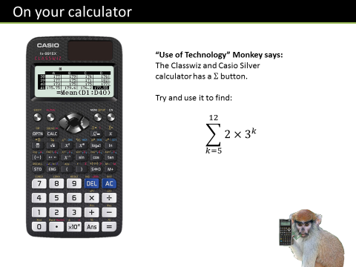Test Your Understanding

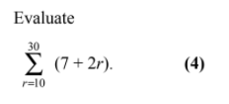

Ex 3F Pg 77