Divergence and Convergence

Sum to Infinity

Quickfire Examples: Calculate a, r and $S_{∞}$ for the following sequences

1. $1,\frac{1}{2},\frac{1}{4},\frac{1}{8},…$

2. $27,-9,3,-1,…$

3. $p, p^{2},p^{3},p^{4},…$ $where -1<p<1$

4. $p, 1,\frac{1}{p},\frac{1}{p^{2}},…$

Examples
1. The fourth term of a geometric series is 1.08 and the seventh term is 0.23328.
- Show that this series is convergent.
- Find the sum to infinity of this series.

2. For a geometric series with first term $a$ and common ratio $r$, $S_{4}=15$ and $S_{∞}=16$.
a) Find the possible values of $r$.
b) Given that all the terms in the series are positive, find the value of $a$.

Test Your Understanding
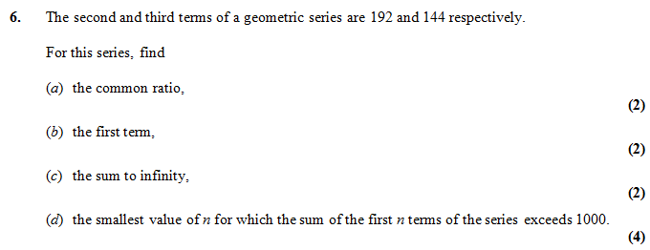

Extension
1. [MAT 2006 1H] How many solutions does the equation
$$2=\sin{x}+\sin^{2}{x}+\sin^{3}{x}+\sin^{4}{x}+…$$
have in the range $0≤x<2π$

2. [MAT 2003 1F] Two players take turns to throw a fair six-sided die until one of them scores a six. What is the probability that the first player to throw the die is the first to score a six?

3. [Frost] Determine the value of $x$ where:
$$x=\frac{1}{1}+\frac{2}{2}+\frac{3}{4}+\frac{4}{8}+\frac{5}{16}+\frac{6}{32}+…$$
(Hint: Use an approach similar to proof of geometric $S_{n}$ formula)

Ex 3E Pg 75

