Sum of terms of Geometric Series

Proof:

Examples

1. Find the sum of the first 10 terms of the following sequences

a)

$$3, 6, 12, 24, 48, …$$

b) $$4, 2,1, \frac{1}{2},\frac{1}{4},\frac{1}{8}, …$$

Example

Find the least value of $n$ such that the sum of $1+2+4+8+…$ to $n$ terms would exceed 2 000 000.

Test Your Understanding

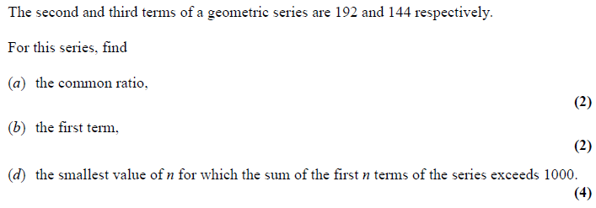

Extension

MAT 2010 1B]

The sum of the first $2n$ terms of

$$1, 1, 2,\frac{1}{2}, 4,\frac{1}{4},8,\frac{1}{8},16,\frac{1}{16},…$$

is



$2^{n}+1-2^{1-n}$

$2^{n}+2^{-n}$

$2^{2n}-2^{3-2n}$

$\frac{2^{n}-2^{-n}}{3}$

Ex 3D Pg 72