Arithmetic Series

Proof of summation (required for exam):

Examples

1. Find the sum of the first 30 terms of the following arithmetic sequences

2. Find the greatest number of terms for the sum of $4+9+14+…$ to exceed 2000

Test Your Understanding

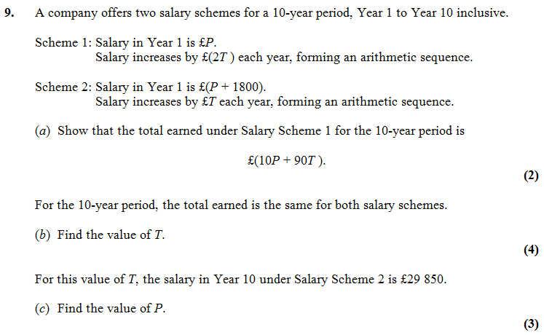

Extension

[MAT 2007 1J]

The inequality

$$\left(n+1\right)+\left(n^{4}+2\right)+\left(n^{9}+3\right)+… +\left(n^{10000}+100\right)>k$$

Is true for all $n≥1$. It follows that



$k<1300$

$k^{2}<101$

$k≥{101}^{10000}$

$k<5150$

[AEA 2010 Q2]

The sum of the first $p$ terms of an arithmetic series is $q$ and the sum of the first $q$ terms of the same arithmetic series is $p$, where $p$ and $q$ are positive integers and $p≠q$.

Giving simplified answers in terms of $p$ and $q$, find

1. The common difference of the terms in this series,
2. The first term of the series,
3. The sum of the first $\left(p+q\right)$ terms of the series.

[MAT 2008 1I]

The function $S\left(n\right)$ is defined for positive integers $n$ by

$S\left(n\right)=$ sum of digits of $n$

For example, $S\left(723\right)=7+2+3=12$.

The sum

$S\left(1\right)+S\left(2\right)+S\left(3\right)+…+S\left(99\right)$

equals what?

Ex 3B Pg 64