13G Finding Areas Between Curves

Option 1:

Option 2:

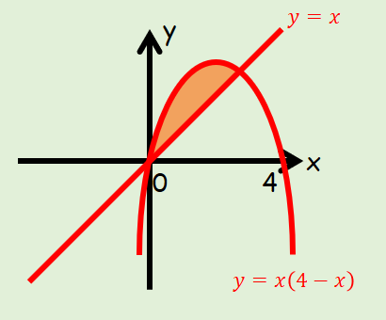
The diagram shows a sketch of part of the curve with equation:
$$y=x(4-x)$$
and the line:
$$y=x$$
Find the area of the region bounded by the curve and the line.

- The diagram below shows a sketch of part of the curve with equation:
$$y=x(x-3)$$
and the line:
$$y=2x$$
Find the area of the shaded region OAC.
