Areas Between Curves and Lines

We are often interested in areas formed between curves and lines. It is important to sketch the graph to consider which areas we need to calculate.

Example
Determine the area between the lines with equations $y=x\left(4-x\right)$ and $y=x$
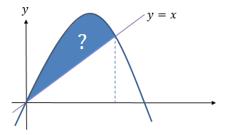

Example
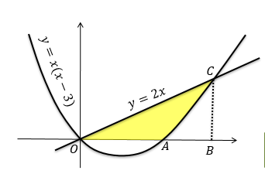
The diagram shows a sketch of the curve with equation $y=x\left(x-3\right)$ and the line with equation $y=2x$.
Find the area of the shaded region $OAC$.

Test Your Understanding

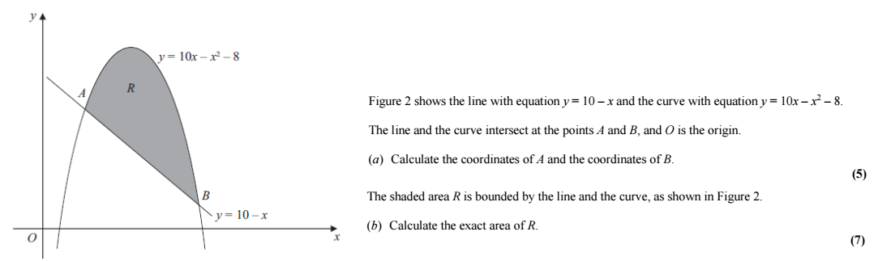

If the top curve has equation $y=f\left(x\right)$ and the bottom curve $y=g\left(x\right)$, the area between them is:
$$\int_{b}^{a}{\left(f\left(x\right)-g\left(x\right)\right) dx}$$
This means you can integrate a single expression to get the final area,
Alternative Method:
If the top curve has equation $y=f\left(x\right)$ and the bottom curve $y=g\left(x\right)$, the area between them is:
$$\int_{b}^{a}{\left(f\left(x\right)-g\left(x\right)\right) dx}$$
This means you can integrate a single expression to get the final area, without any adjustment required after.

Extension
[MAT 2005 1A] What is the area of the region bounded by the curves $y=x^{2}$ and $y=x+2$?

[MAT 2016 1H] Consider two functions
$$f\left(x\right)=a-x^{2}g\left(x\right)=x^{4}-a$$
For precisely which values of $a>0$ is the area of the region bounded by the $x$-axis and the curve $y=f\left(x\right)$ bigger than the area of the region bounded by the $x$-axis and the curve $y=g\left(x\right)$?
(Your answer should be an inequality in terms of $a$)

Ex 13G pg 304

