Negative Areas

Sketch the curve $y=x(x-1)(x-2)$.

Now calculate $\int_{0}^{2}{x\left(x-1\right)\left(x-2\right)} dx$.

Why is this result surprising?

Integration $∫f\left(x\right) dx$ is just the sum of areas of infinitely thin rectangles, where the current $y$ value (i.e. $f(x)$) is each height, and the widths are $dx$.
i.e. The area of each is $f\left(x\right)×dx$
The problem is, when $f(x)$ is negative, then $f\left(x\right)×dx$ is negative, i.e. a negative area!
The result is that the ‘positive area’ from 0 to 1 is cancelled out by the ‘negative area’ from 1 to 2, giving an overall ‘area’ of 0.
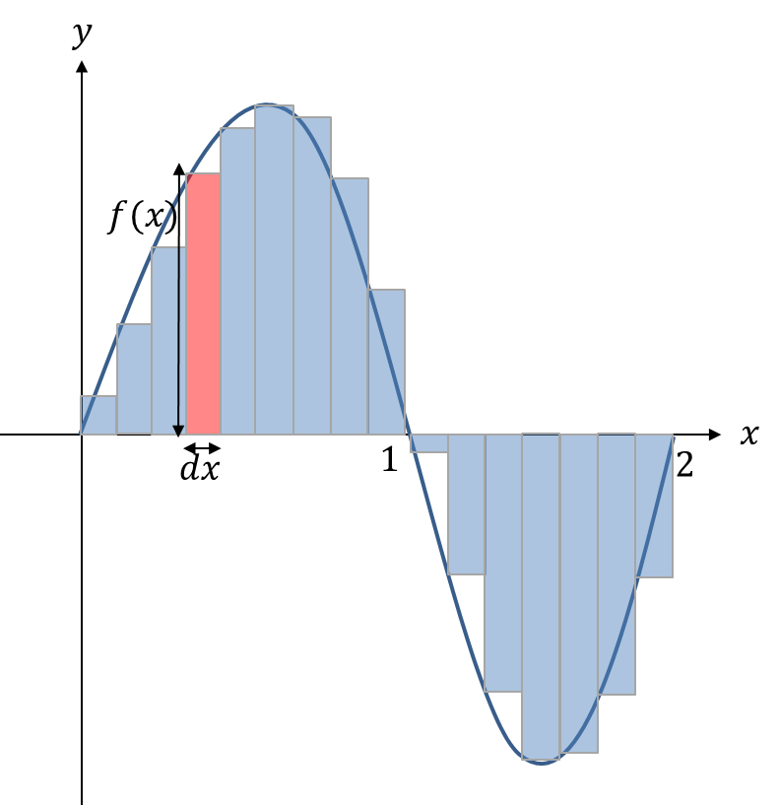
So how do we resolve this?

This explains the $dx$ in the $\int{f\left(x\right) dx}$, which effectively means “the sum of the areas of strips, each of area $f\left(x\right)×dx$. So the $dx$ is not just part of the $∫$ notation, it’s behaving as a physical quantity! (i.e. length

Example
Find the total area bound between the curve $y=x(x-1)(x-2)$ and the $x$-axis.
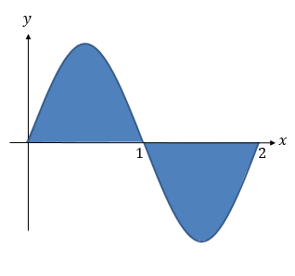

Test Your Understanding

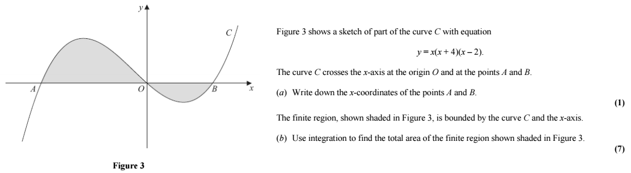

Extension
[MAT 2010 1I] For a positive number $a$, let
$$I\left(a\right)=\int_{0}^{a}{\left(4-2^{x^{2}}\right)dx}$$
Then $\frac{dI}{da}=0$ when $a$ is what value?

[STEP I 2014 Q3]
The numbers $a$ and $b$, where $b>a≥0$, are such that
$$\int_{a}^{b}{x^{2} dx}={\left(\int_{a}^{b}{x dx}\right)}^{2}$$
- In the case $a=0$ and $b>0$, find the value of $b$.
- In the case $a=1$, show that $b$ satisfies
$$3b^{3}-b^{2}-7b-7=0$$Show further, with the help of a sketch, that there is only one (real) value of $b$ that satisfies the equation and that it lies between 2 and 3.
- Show that $3p^{2}+q^{2}=3p^{2}q$, where $p=b+a$ and $q=b-a$, and express $p^{2}$ in terms of $q$. Deduce that $1<b-a≤\frac{4}{3}$

Ex 13F pg 301

