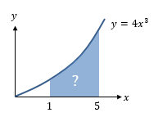
Areas Under Curves
Consider our previous example $\int_{1}^{5}{4x^{3} dx}$. This definite integral gives the area bounded by the curve and the lines x = 1 and x = 5.

The definite integral $\int_{b}^{a}{f(x)} dx$ gives the area between a positive curve $y=f(x)$, the $x$-axis, and the lines $x=a$ and $x=b$.

Example
Find the area of the finite region between the curve with equation $y=20-x-x^{2}$ and the $x$-axis.

Test Your Understanding
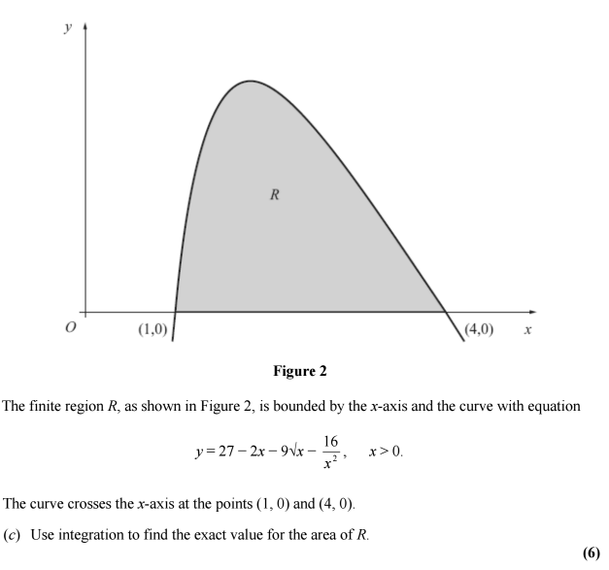

Extension
[MAT 2007 1H] Given a function $f(x)$, you are told that
$$\int_{0}^{1}{3f\left(x\right) dx}+\int_{1}^{2}{2f\left(x\right) dx}=7\int_{0}^{2}{f\left(x\right) dx}+\int_{1}^{2}{f\left(x\right) dx}=1$$
It follows that $\int_{0}^{2}{f(x)} dx$ equals what?

[MAT 2011 1G]
A graph of the function $y=f\left(x\right)$ is sketched on the axes below:
What is the value of $\int_{-1}^{1}{f(x^{2}-1)} dx$?

Ex 13E pg 299

