Finding the Constant of Integration

Recall that when we integrate, we get a constant of integration, which could be any real value. This means we don’t know what the exact original function was.

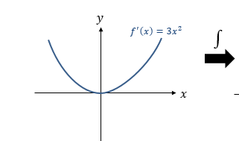
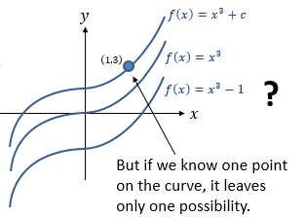

Example
The curve with equation $y=f(x)$ passes through $\left(1,3\right)$. Given that $f^{'}\left(x\right)=3x^{2}$, find the equation of the curve.

Test Your Understanding
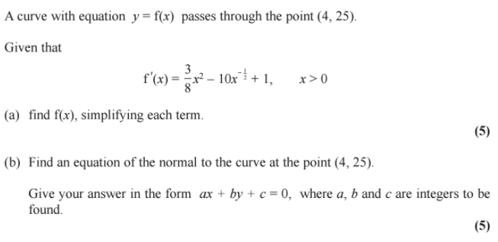

Ex 13C pg 294

