Integration Notation

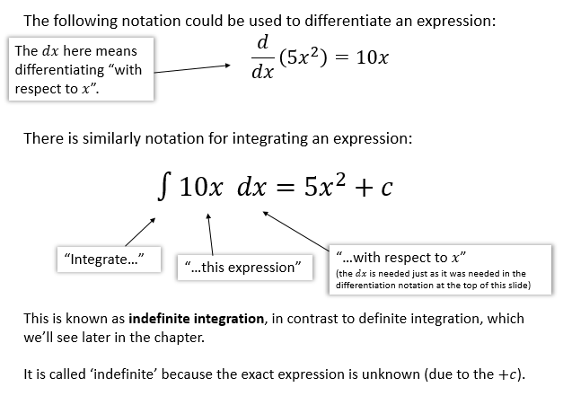

Examples
- Find $\int{(x^{-\frac{3}{2}}+2) dx}$ 2. Find $\int{(6t^{2}-1) dt}$

3. Find $\int{(px^{3}+q) dx}$ where $p$ and $q$ are constants.

Test Your Understanding

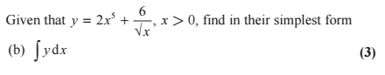

Ex 13B pg 291

