Lower 6 Chapter 13
Integration

Course Structure
- Find $y$ given $\frac{dy}{dx}$
- Evaluate definite integrals, and hence the area under a curve.
- Find areas bound between two different lines.

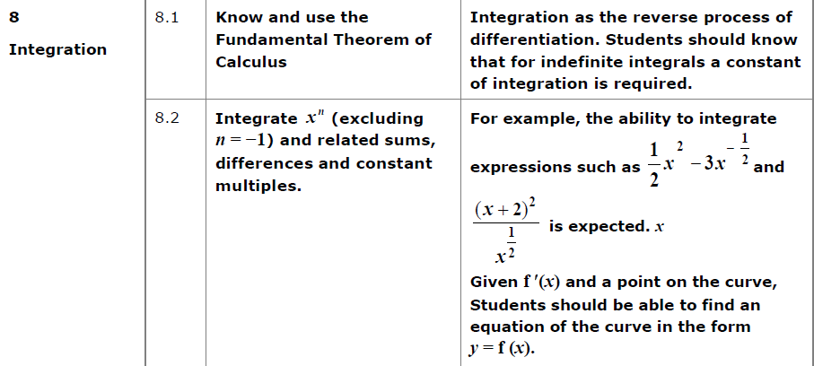
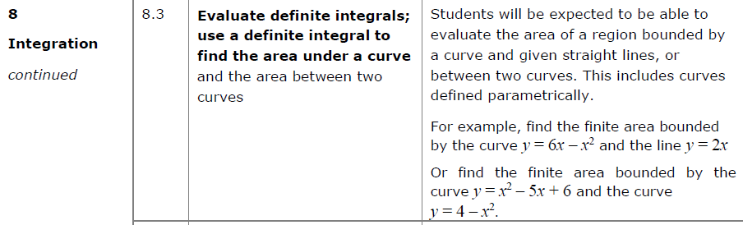

Integrating $x^{n}$ terms

Integration is the opposite of differentiation.

Consider:
If $\frac{dy}{dx}=3x^{2}$, what could $f(x)$?

Examples
Find $y$ when:
- $\frac{dy}{dx}=4x^{3} 2. \frac{dy}{dx}=x^{5}$

$3. \frac{dy}{dx}=3x^{\frac{1}{2}}$ 4. $\frac{dy}{dx}=\frac{4}{\sqrt{x}}$

$5. \frac{dy}{dx}=5x^{-2}$ 6. $\frac{dy}{dx}=4x^{\frac{2}{3}}$

7. $\frac{dy}{dx}=10x^{-\frac{2}{7}}$

Test Your Understanding

Find $f(x)$ when:

$f^{'}\left(x\right)=2x+7$ $f^{'}\left(x\right)=x^{2}-1$

$f^{'}\left(x\right)=\frac{2}{x^{7}}$ $f^{'}\left(x\right)=\sqrt[3]{x}=$

$f^{'}\left(x\right)=33x^{\frac{5}{6}}$

Ex 13A pg 289

