Application to Mechanics

Out of displacement, speed, acceleration, force, mass and time, all but mass and time are vectors. Clearly these can act in 3D space.
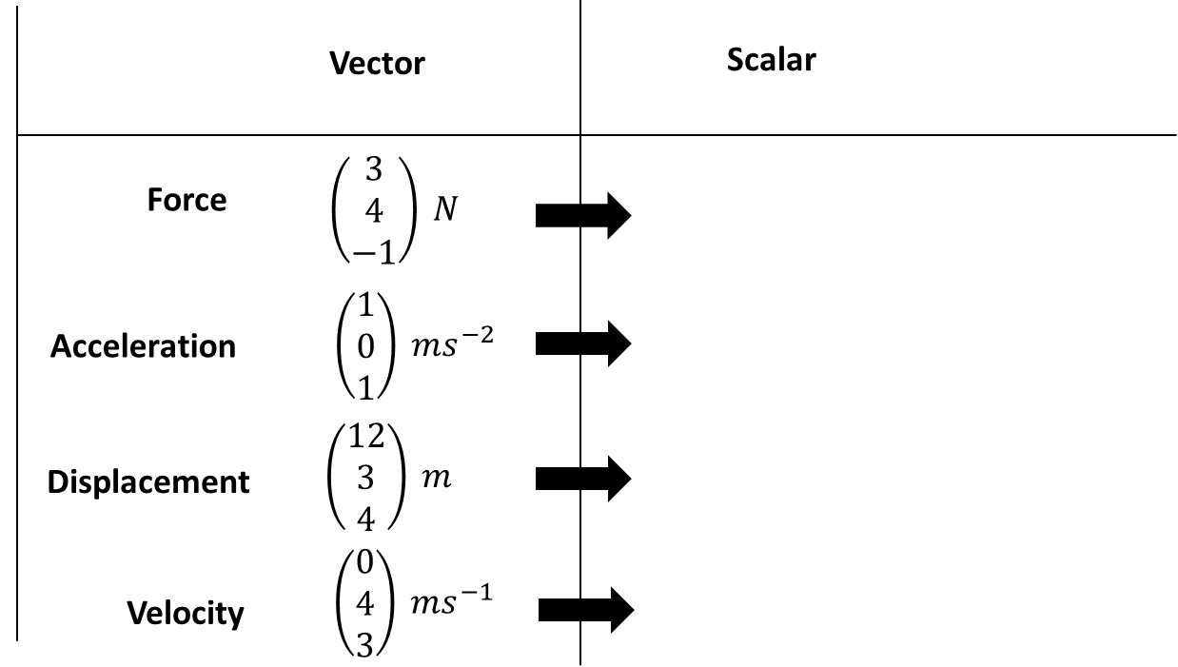

Example

[Textbook] A particle of mass 0.5 kg is acted on by three forces.
$$F_{1}=\left(2i-j+2k\right) NF_{2}=\left(-i+3j-3k\right) NF_{3}=\left(4i-3j-2k\right) N$$
- Find the resultant force $R$ acting on the particle.
- Find the acceleration of the particle, giving your answer in the form $\left(pi+qj+rk\right)$ ms⁻².
- Find the magnitude of the acceleration.
Given that the particle starts at rest,
d. Find the distance travelled by the particle in the first 6 seconds of its motion.

Ex 12D p.348-349

