$i$, $j$ and $k$ notation
In 2D you were previously introduced to $i=\left(\begin{matrix}1 \\ 0 \end{matrix}\right)$ and $j=\left(\begin{matrix}0 \\ 1\end{matrix}\right)$ as unit vectors in each of the $x$ and $y$ directions.
It meant for example that $\left(\begin{matrix}8 \\ -2\end{matrix}\right)$ could be written as $8i-2j$ since $8\left(\begin{matrix}1 \\ 0 \end{matrix}\right)-2\left(\begin{matrix}0 \\ 1\end{matrix}\right)=\left(\begin{matrix}8 \\ -2\end{matrix}\right)$

Unsurprisingly, in 3D:
$$i=\left(\begin{matrix}1 \\ 0 \\ 0\end{matrix}\right), j=\left(\begin{matrix}0 \\ 1 \\ 0\end{matrix}\right), k=\left(\begin{matrix}0 \\ 0 \\ 1\end{matrix}\right)$$
Quickfire Questions
- Put in $i,j,k$ notation:
$$\left(\begin{matrix}1 \\ 2 \\ 3\end{matrix}\right)=$$

$$\left(\begin{matrix}3 \\ 0 \\ -1\end{matrix}\right)=$$

- Write as a column vector:
$$4j+k=$$

$$i-j=$$

- If $A\left(1,2,3\right), B\left(4,0,-1\right)$ then
$$\vec{AB}=$$

- If $a=\left(\begin{matrix}2 \\ 3 \\ 4\end{matrix}\right)$ and $b=\left(\begin{matrix}0 \\ -1 \\ 3\end{matrix}\right)$ then $3a+2b=$

Examples
- Find the magnitude of $a=2i-j+4k$ and hence find $\hat{a}$, the unit vector in the direction of $a$.

- If $a=\left(\begin{matrix}2 \\ -3 \\ 5\end{matrix}\right)$ and $b=\left(\begin{matrix}4 \\ -2 \\ 0 \end{matrix}\right)$ is $2a-3b$ parallel to $4i-5k$?

Angles between vectors and an axis
How could you work out the angle between a vector and the $x$-axis?
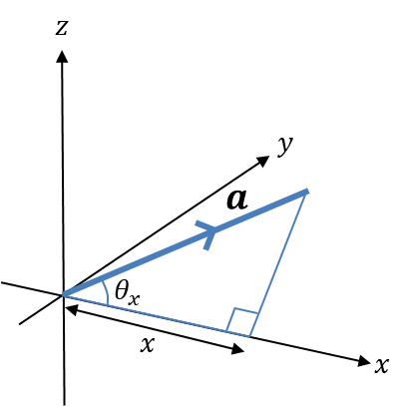

- The angle between $a=\left(\begin{matrix}x \\ y \\ z\end{matrix}\right)$ and the $x$-axis is:
$$\cos{θ_{x}}=\frac{x}{\left|a\right|}$$
and similarly for the $y$ and $z$ axes.

[Textbook] Find the angles that the vector $a=2i-3j-k$ makes with each of the positive coordinate axis.

Test Your Understanding

[Textbook] The points $A$ and $B$ have position vectors $4i+2j+7k$ and
$3i+4j-k$ relative to a fixed origin, $O$. Find $\vec{AB}$ and show that $ΔOAB$ is isosceles.

(a) Find the angle that the vector $a=2i+j+k$ makes with the $x$-axis.
(b) By similarly considering the angle that $b=i+3j+2k$ makes with the $x$-axis, determine the area of $OAB$ where $\vec{OA}=a$ and $\vec{OB}=b$. (Hint: draw a diagram)

Ex 12B p.341-343

