**Pure 2**

**Vectors**

Chapter Overview

1:: Distance between two points.

2:: $i,j,k$ notation for vectors

3:: Magnitude of a 3D vector and using it to find angle between vector and a coordinate axis.

4:: Solving Geometric Problems

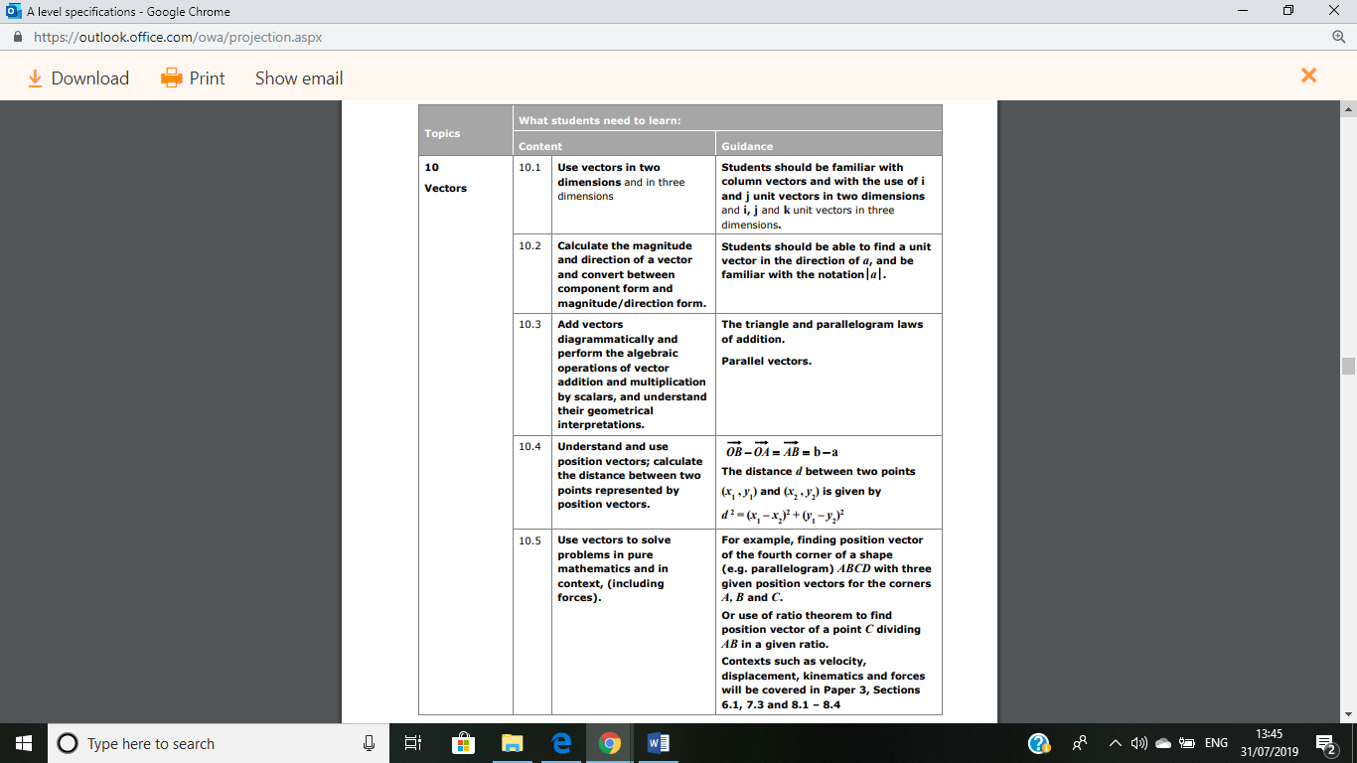5:: Application to Mechanics

**Distance from the origin and magnitude of a vector**

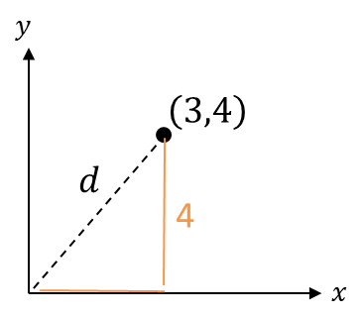 In 2D, how did we find the distance from a point to the origin?

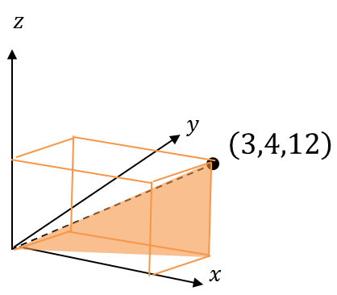



**The magnitude of a vector $a=\left(\begin{matrix}x \\ y \\ z\end{matrix}\right)$:**

$$\left|a\right|=\sqrt{x^{2}+y^{2}+z^{2}}$$

**And the distance of $(x,y,z)$ from the origin is $\sqrt{x^{2}+y^{2}+z^{2}}$**

**Distance between two 3D points**

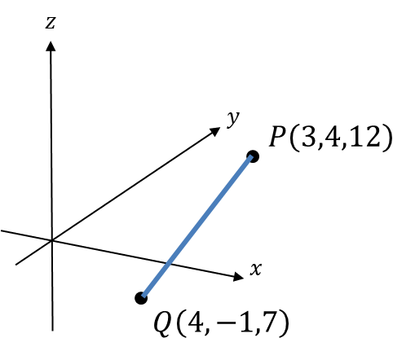

How do we find the distance between $P$ and $Q$?

**The distance between two points is:**

$$d=\sqrt{{\left(Δx\right)}^{2}+{\left(Δy\right)}^{2}+{\left(Δz\right)}^{2}}$$

$Δx$**means “change in $x$”**

**Quickfire Questions:**

Distance of $(4,0,-2)$ from the origin:

$$\left|\left(\begin{matrix}5 \\ 4 \\ -1\end{matrix}\right)\right|=$$

Distance between $(0,4,3)$ and $\left(5,2,3\right).$

Distance between $(1,1,1)$ and $\left(2,1,0\right).$

Distance between $(-5,2,0)$ and $\left(-2,-3,-3\right).$

**Tip**: Because we’re squaring, it doesn’t matter whether the change is negative or positive.

***Test Your Understanding So Far…***

[Textbook] **Find the distance from the origin to the point $P(7,7,7)$.**

[Textbook] **The coordinates of $A$ and $B$ are $(5,3,-8)$ and $\left(1,k,-3\right)$ respectively. Given that the distance from $A$ to $B$ is $3\sqrt{10}$ units, find the possible values of $k$.**

Ex 12A p.338