11I The Trapezium Rule

- Using 4 strips, estimate the area under the curve:
$$y=\sqrt{2x+3}$$
Between the lines x = 0 and x = 2

- Using 8 strips, estimate the area under the curve:
$$y=\sqrt{2x+3}$$
Between the lines x = 0 and x = 2

- Complete the table of values and use it to find an estimate for:
$$\int_{0}^{\frac{π}{3}}{secx dx}$$
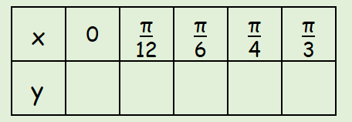

- Use the trapezium rule with 4 strips to find an approximation for:
$$\int_{0}^{2}{xsinx dx}$$

