11H Part 1 Integrating to Find Areas
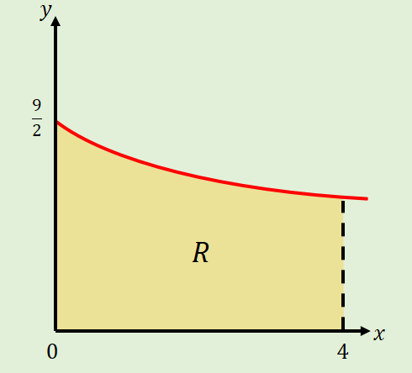
- The diagram shows part of the curve:
$$y=\frac{9}{\sqrt{4+3x}}$$
The region $R$ is bounded by the curve, the x-axis, and the lines $x=0$ and $x=4$, and shown. Use integration to find the area of $R$.

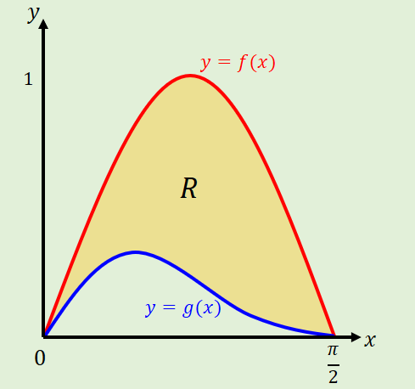
- The diagram shows part of the curves $y=f(x)$ and $y=g(x)$, where:
$$f\left(x\right)=sin2x$$
$$g\left(x\right)=sinx\cos^{2}x$$
$$0≤x≤\frac{π}{2}$$
The region $R$ is bounded by the two curves. Use integration to find the area of $R$.

