Modelling with vectors

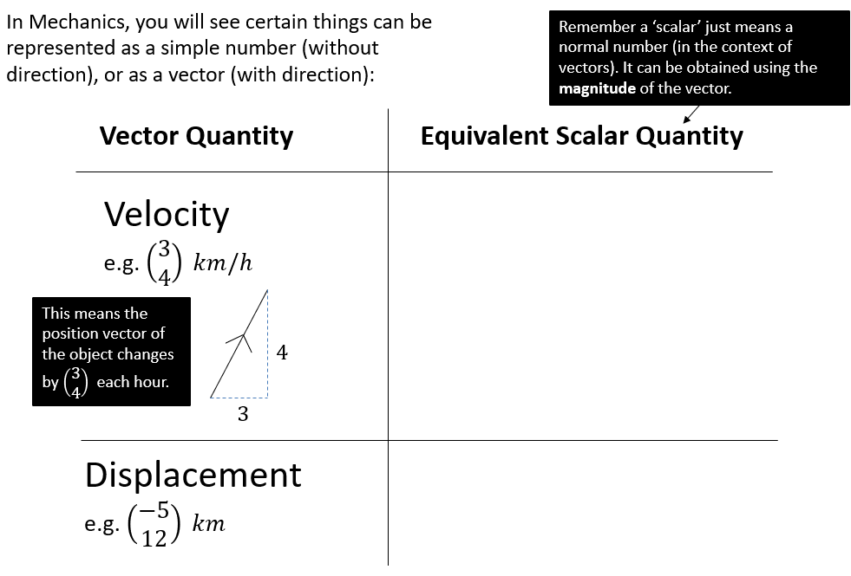

Examples
- A girl walks 2 km due east from a fixed point $O$ to $A$, and then 3 km due south from $A$ to $B$. Find
- the total distance travelled
- the position vector of $B$ relative to $O$
- $\left|\vec{OB}\right|$
- The bearing of $B$ from $O$.

- In an orienteering exercise, a cadet leaves the starting point $O$ and walks 15 km on a bearing of $120°$ to reach $A$, the first checkpoint. From $A$ he walks 9 km on a bearing of $240°$ to the second checkpoint, at $B$. From $B$ he returns directly to $O$.

Find:
- the position vector of $A$ relative to $O$
- $\left|\vec{OB}\right|$
- the bearing of $B$ from $O$
- the position vector of $B$ relative $O$.

Exercise 11F Pg 250/251

AD Page 11

