More examples
Use the substitution $u^{2}=x+1$ to find $\int{\frac{ x}{ {\left(x + 1\right)}^{\frac{1}{2}}}}dx$

Example 4
Use the substitution $x=\frac{2}{3}\tan{u}$ to find $\int{\frac{ 1}{ 4+9x^{2}}}dx$

Edexcel will usually give you the substitution in the exam question.
However, if you are not provided with a substitution, a ‘rule of thumb’ is to replace expressions inside roots, powers or the denominator of a fraction by the variable u.
INTEGRATION BY SUBSTITUTION AND DEFINITE INTEGRALS
When you use integration by substitution to evaluate a definite integral, you do not need to rewrite the expression in terms of $x$. However, if you use the expression in terms of $u$, you must replace the $x$ limits with $u$ limits.
Alternatively, you could convert the integral back to a function of $x$ and use the original limits but this is usually messier!

Example 5
Calculate $\int_{0}^{\frac{π}{2}}{\cos{x}\sqrt{1+\sin{x}}} dx$

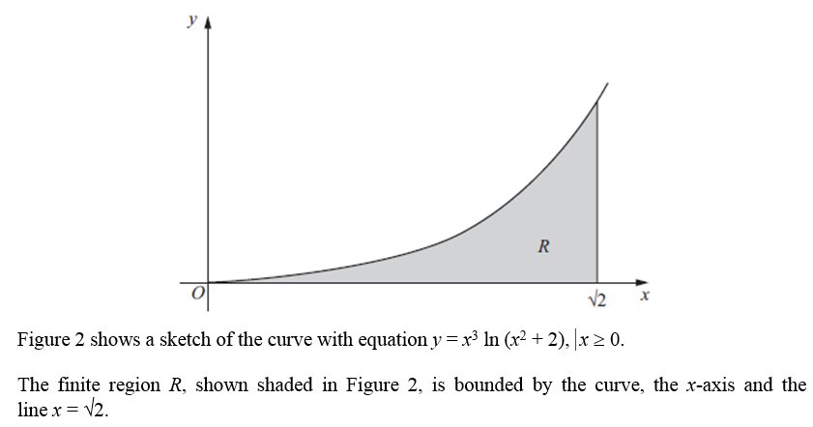
Example 6
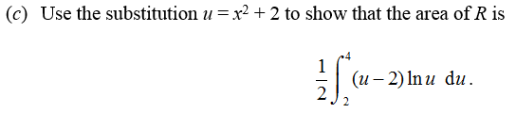

Exercise 11E Page 306

