11E Geometric Problems
- In the diagram the points A and B have position vectors a and b respectively. The point P divides line AB in the ratio 1:2. Find the position vector of P

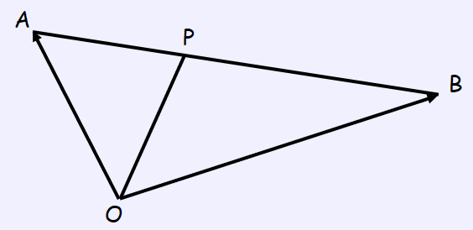

- In triangle $ABC$, $\vec{AB}=3i-2j$ and $\vec{AC}=i-5j$. Find the size of $∠BAC$ in degrees.

- OABC is a parallelogram. P is the point where OB and AC intersect.
The vectors a and c represent OA and OC respectively.
Prove that the diagonals bisect each other.

