Solving Geometric Problems

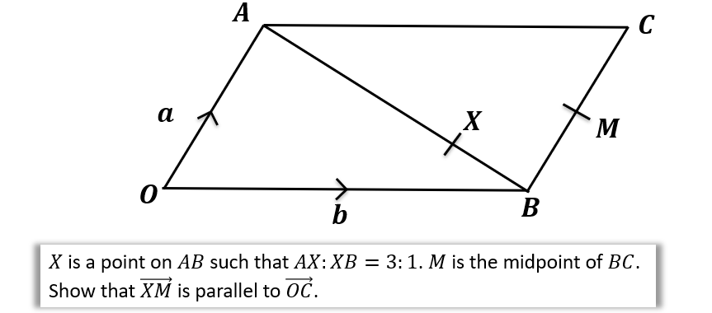

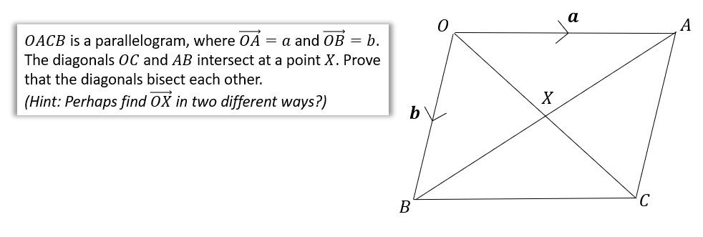

Test your understanding
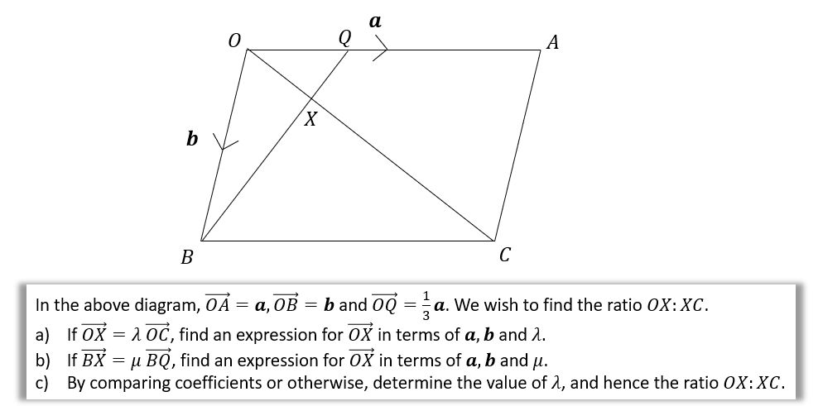

Area of a triangle example
If $\vec{AB}=3i-2j$ and $\vec{AC}=i-5j$. Determine $∠BAC$.

Extension
[STEP 2010 Q7]
Relative to a fixed origin $O$, the points $A$ and $B$ have position vectors $a$ and $b$, respectively. (The points $O, A$ and $B$ are not collinear.) The point $C$ has position vector $c$ given by
$$c=αa+βb,$$
where $α$ and $β$ are positive constants with $α+β<1$. The lines $OA$ and $BC$ meet at the point $P$ with position vector $p$ and the lines $OB$ and $AC$ meet at the point $Q$ with position vector $q$. Show that
$$p=\frac{αa}{1-β}$$
and write down $q$ in terms of $α, β$ and $b$.
Show further that the point $R$ with position vector $r$ given by
$$r=\frac{αa+βb}{α+β},$$
lies on the lines $OC$ and $AB$.
The lines $OB$ and $PR$ intersect at the point $S$. Prove that $\frac{OQ}{BQ}=\frac{OS}{BS}$.

Exercise 11E Pg 246/247

AD Page 11

