Magnitude of a vector
The magnitude $|a|$ of a vector $a$ is its length.
If $aIf a=\left(\begin{matrix}x \\ y\end{matrix}\right) \left|a\right|=\sqrt{x^{2}+y^{2}}$
Examples:

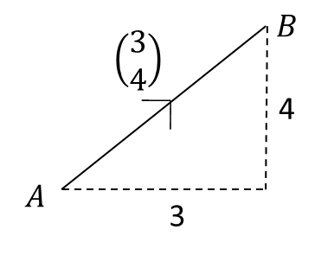

$2. a=\left(\begin{matrix}4 \\ -1\end{matrix}\right)$ $3. b=\left(\begin{matrix}2 \\ 0\end{matrix}\right)$

Direction of a Vector
The direction of a vector can be found using basic trigonometry.

Examples
1. Find the angle that vector$a=\left(\begin{matrix}4 \\ -1\end{matrix}\right)$ makes with the positive x axis.

2. Find the angle that vector$b=\left(\begin{matrix}-5 \\ -12\end{matrix}\right)$ makes with j.

Unit vector
A unit vector is a vector whose magnitude is 1.
If $a$ is a vector, then the unit vector $\hat{a}$in the same direction is

$$\hat{a}=\frac{a}{\left|a\right|}$$
Example:

Find a unit vector in the direction of $a=\left(\begin{matrix}3 \\ 4\end{matrix}\right)$

Test Your Understanding: Convert the following vectors to unit vectors.

$a=\left(\begin{matrix}12 \\ -5\end{matrix}\right)$ $b=\left(\begin{matrix}1 \\ 1\end{matrix}\right)$

Exercise 11C Pg 240/241

AD Page 11

