Lower 6 Chapter 11
Vectors

Chapter Overview
- Add/scale factors and show vectors are parallel.
- Calculate magnitude and direction of a vector.
- Understand and use position vectors.
- Solve geometric problems.
- Understand speed vs velocity.

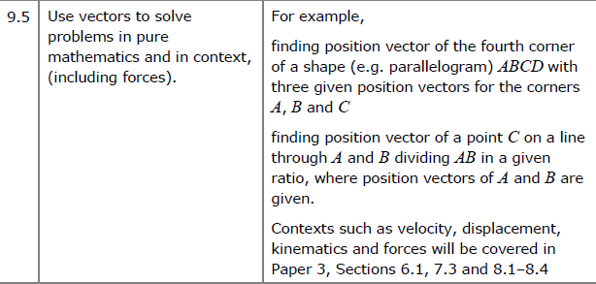
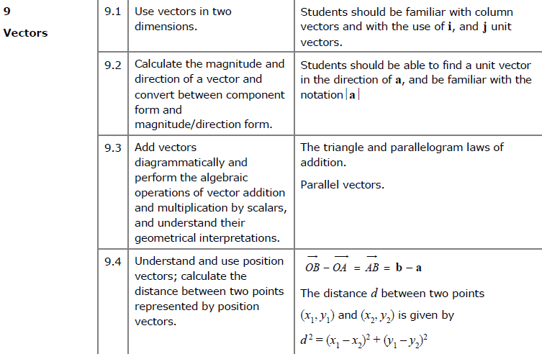

Vector basics

Whereas a coordinate represents a position in space, a vector represents a displacement in space.

- A vector has 2 properties:
- Direction
- Magnitude (i.e. length)

If $P$ and $Q$ are points then $\vec{PQ}$ is the vector between them.

- If two vectors $\vec{PQ}$ and $\vec{RS}$ have the same magnitude and direction, they’re the same vector and are parallel.

- $\vec{AB}=-\vec{BA}$ and the two vectors are parallel, equal in magnitude but in opposite directions.

- Triangle Law for vector addition:

$$\vec{AB}+\vec{BC}=\vec{AC}$$

The vector of multiple vectors is known as the resultant vector. (you will encounter this term in Mechanics)

- Vector subtraction is defined using vector addition and negation:
$$a-b=a+\left(-b\right)$$

- The zero vector $0$ (a bold 0), represents no movement.

$$\vec{PQ}+\vec{QP}=0$$

In 2D: $0=\left(\begin{matrix}0 \\ 0\end{matrix}\right)$

- A scalar is a normal number, which can be used to ‘scale’ a vector.
- The direction will be the same.
- But the magnitude will be different (unless the scalar is 1).

- Any vector parallel to the vector $a$ can be written as $λa$, where $λ$ is a scalar.

The implication is that if we can write one vector as a multiple of another, then we can show they are parallel.

Example
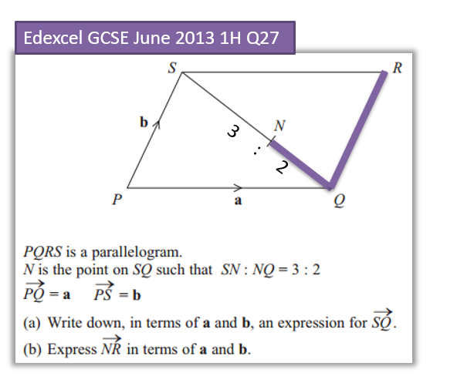

Test your understanding
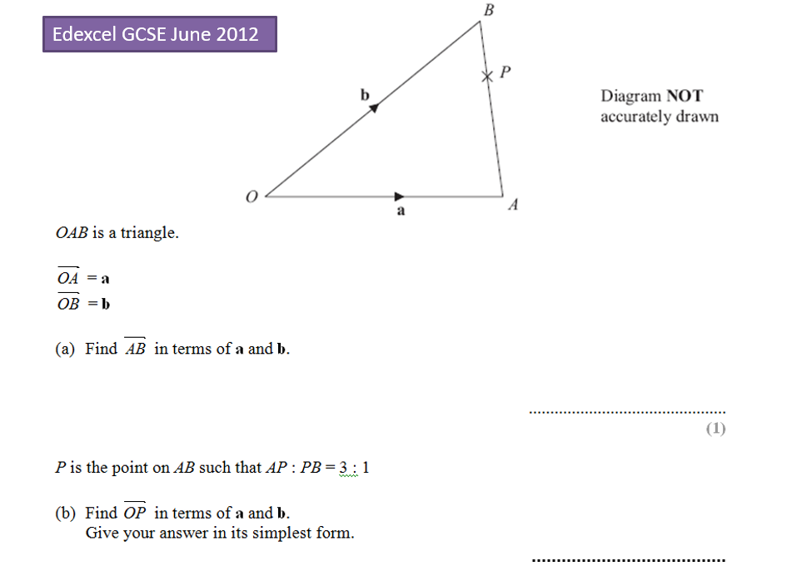

Exercise 11A Pg 234/235

AD Page 11

