Upper 6 Chapter 11

Integration

Chapter Overview

1. Integration
2. Integrals of the form $f'\left(ax+b\right)$
3. Using Trigonometric Identities
4. The Reverse Chain Rule
5. Integration by Substitution
6. Integration by Parts
7. Integration Using Partial Fractions
8. Area Under a Curve
9. The Trapezium Rule
10. Parametric Equations
11. Differential Equations
12. Forming Differential Equations







**INTEGRATION**

Integration is the reverse of differentiation. We use known derivatives to integrate.

**The following are integrals that you should know:**

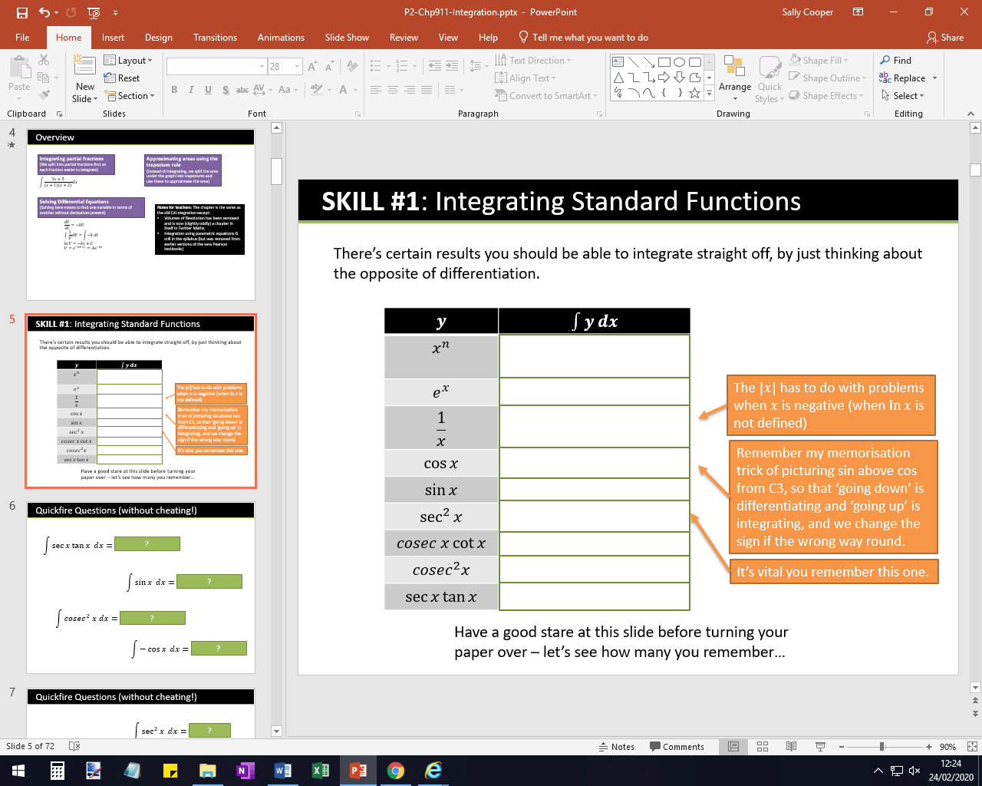

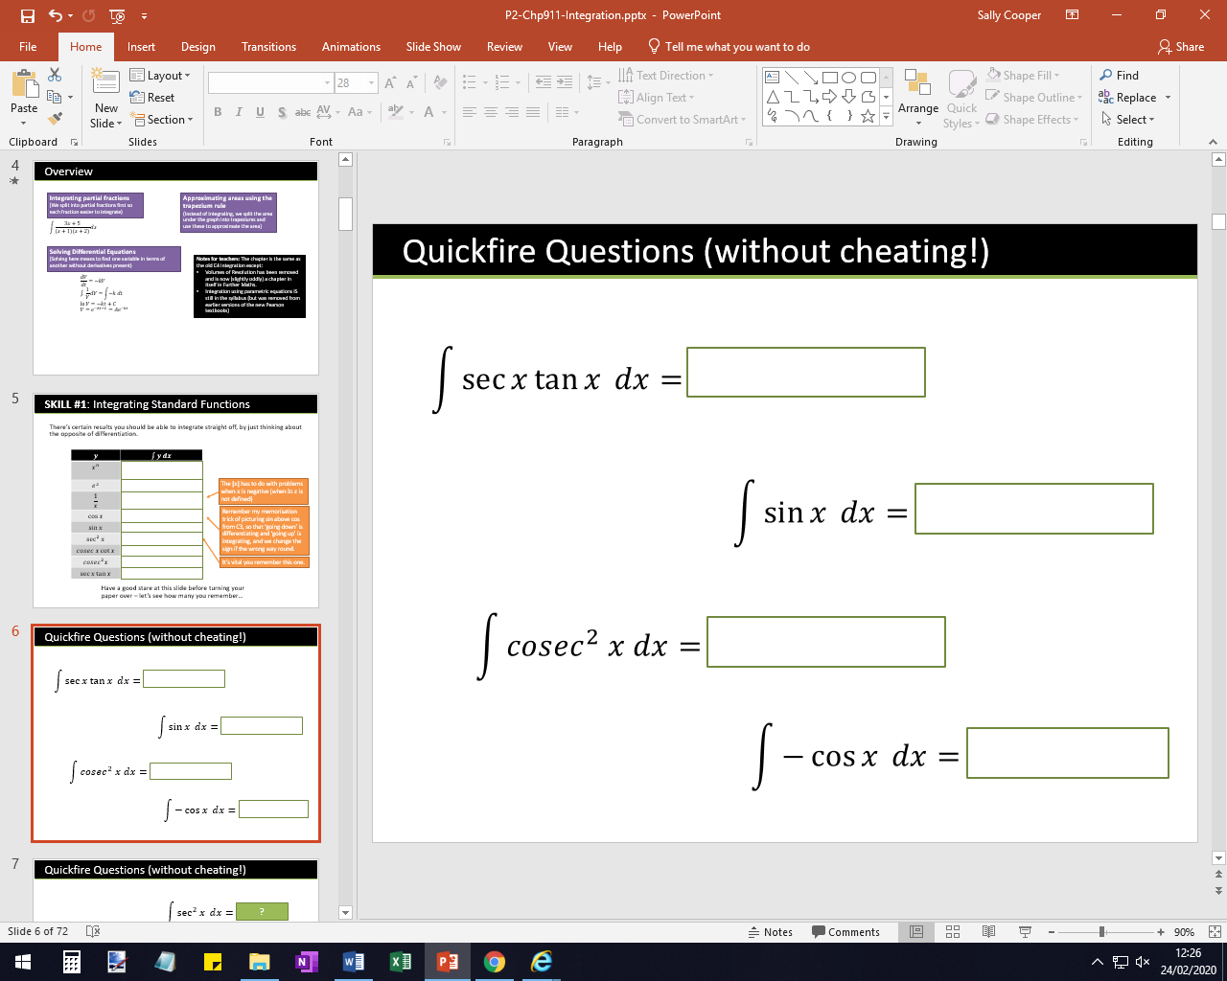

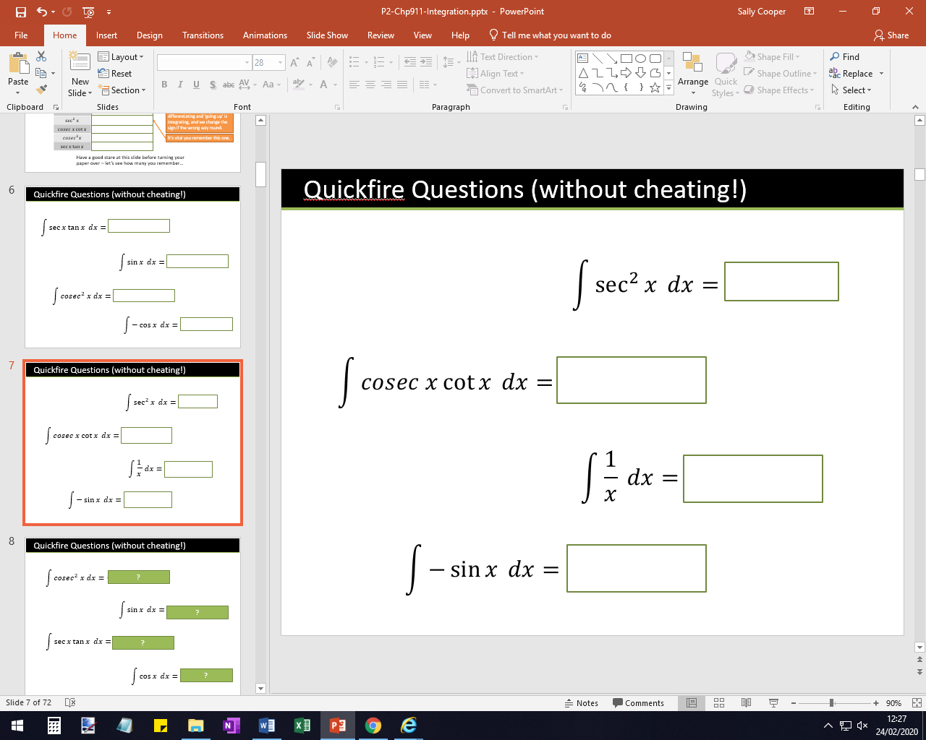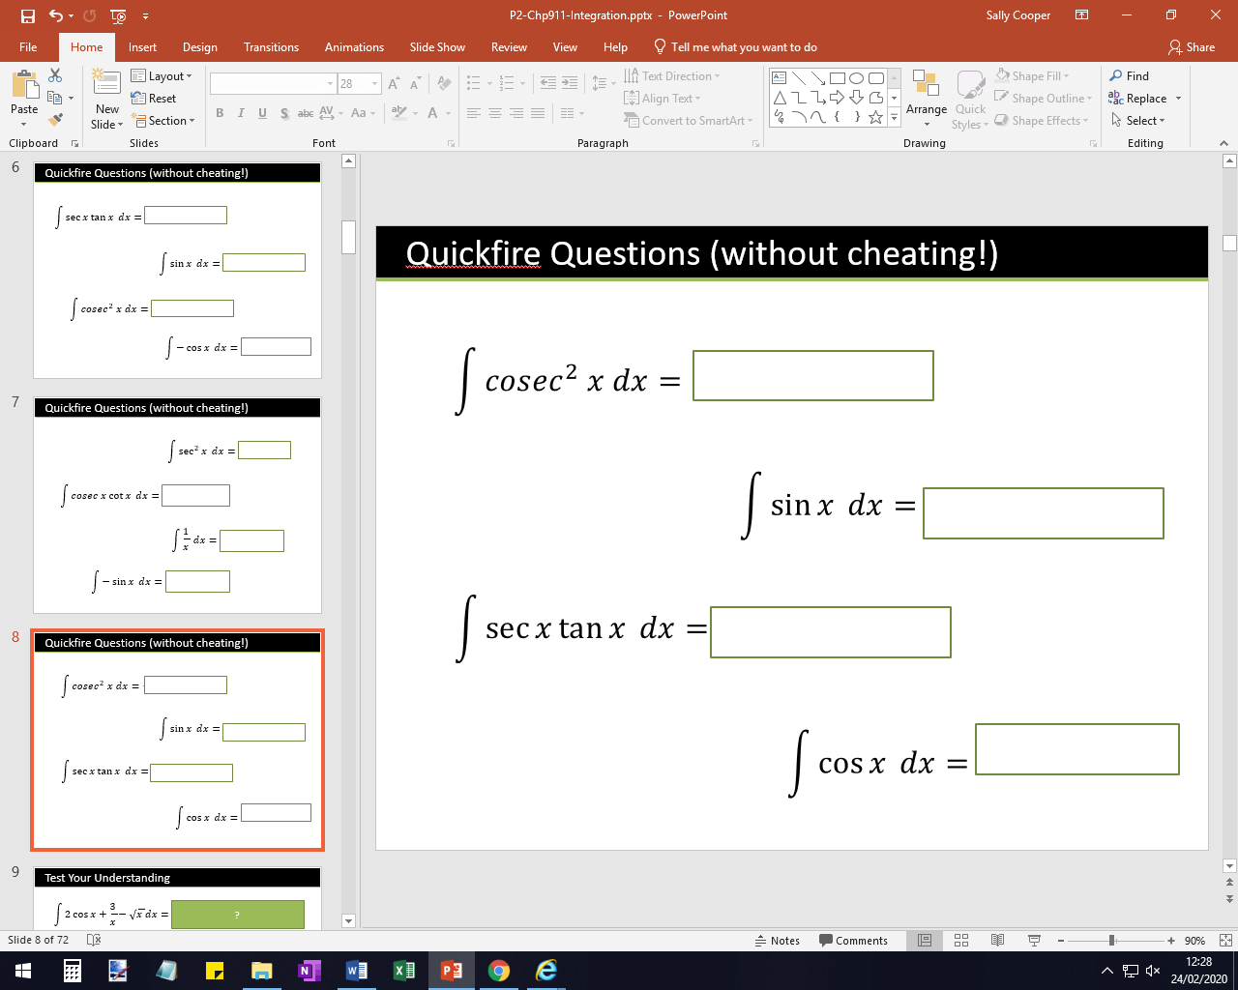

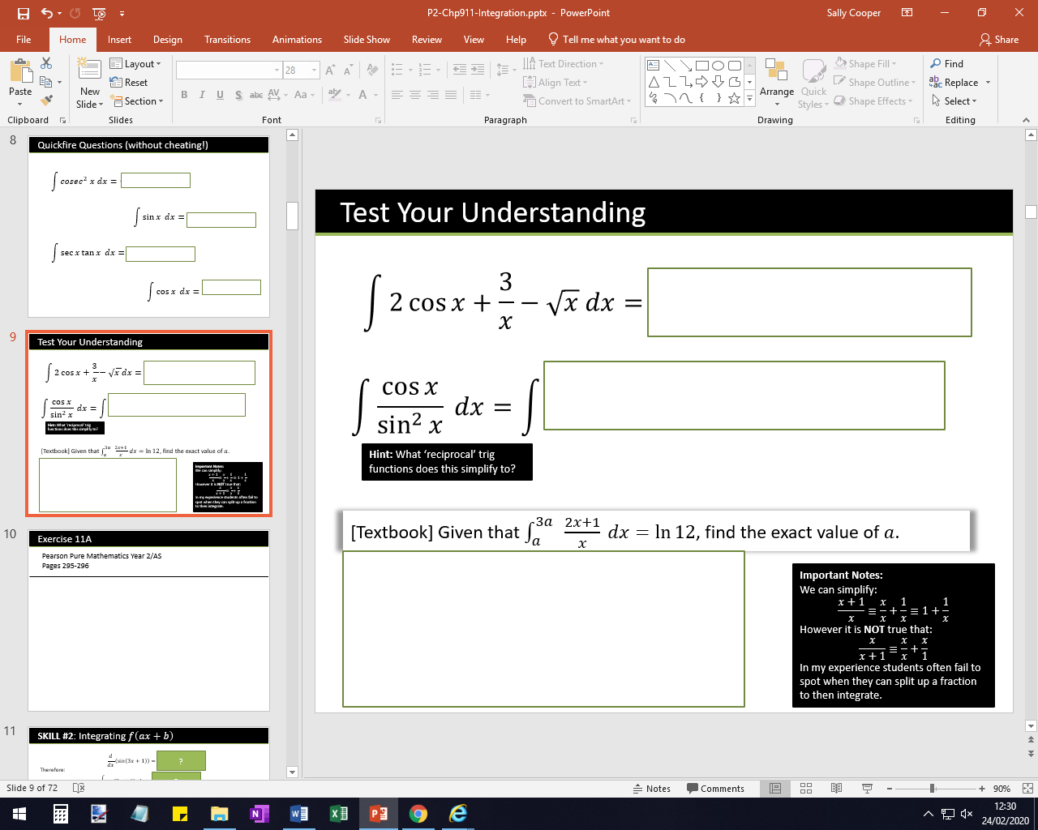

Exercise 11A Page 295